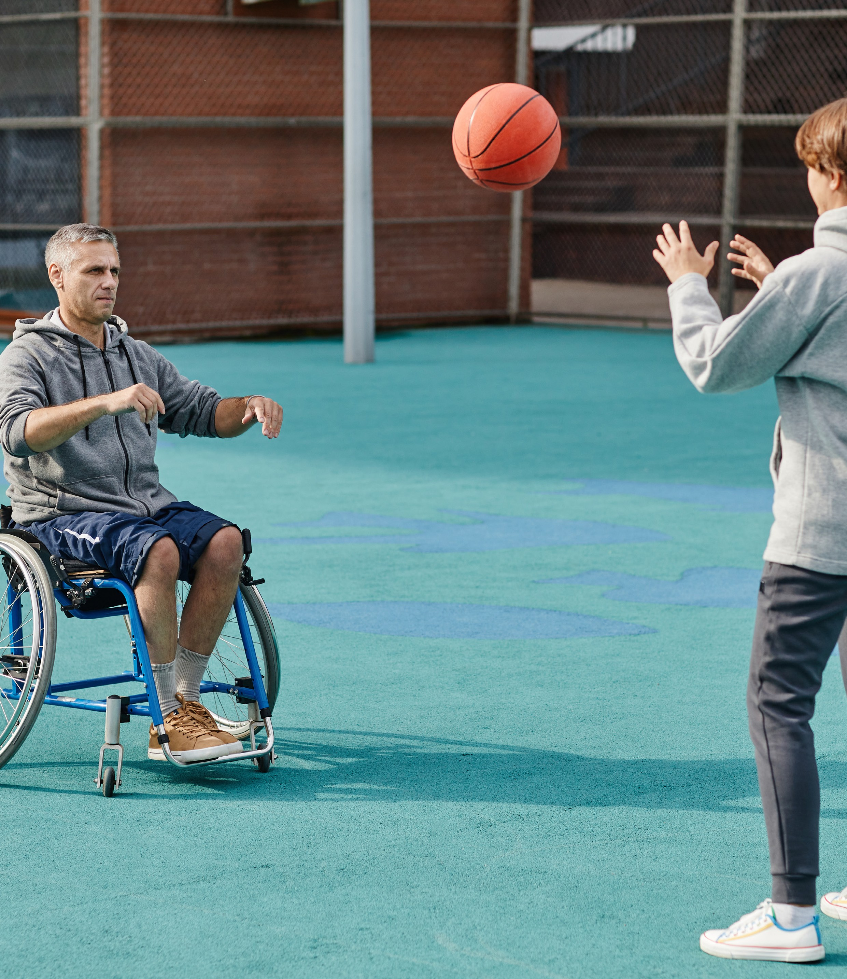
SAFE FAIR INCLUSIVE SPORT
Issue 40

– Life As a Powerchair Football Athlete

PLUS
Winyarr Ganbina/Women arise

Volunteer tips from Club Respect Officially Human USA
New federal government adopts key Respect@Work recommendation
Her Way – Abbie
Play By The Rules | Magazine Issue 40 1

2 Play By The Rules | Magazine Issue 40

CONTENTS

State/territory
3
Play by the Rules contacts
4 The Editor Women Arise Winyarr Ganbina
6

Club Respect: Volunteer Tips
8
10 Kicking goals
12 Respect@Work
Global Resistance to referee abuse: Officially Human (U.S.A)
14

Her Way – A young sports fan makes her own path
24

Subscribe to Play by the Rules Back issues
26
Share and spread the word

Play by the Rules and Sport Integrity Australia courses in one place
27

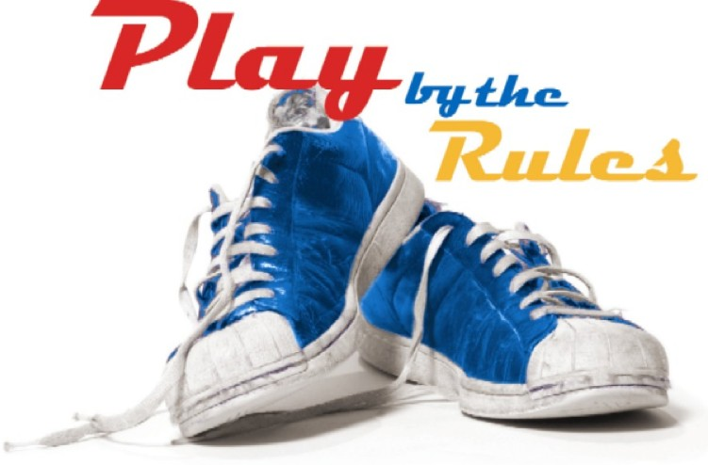

State/ Territory Contacts Calendar

Play By The Rules | Magazine Issue 40 3

THE EDITOR

Can sporting events and action on inclusion and diversity score goals together?

When large-scale sporting events are on, we hear the stories of the triumphs and challenges of the athletes and their journeys to their starting line, they inspire us with their feats of determination and resilience. I’m always impressed by what it must take to even be in the race.
However, what about the events themselves? The sheer work of getting right the logistics, machinations of a workforce, facilities, sponsors,
media, and community of people and fans to come together for a moment in time is breathtaking. So why not also look to the event itself as the source of inspiration for a better world?
As someone who has always been passionate about inclusion and diversity, I see the real potential that major sport can play in breaking down the barriers that exclude and separate us. If a game of football can unite the world, surely, we can move the dial on discrimination and inclusion as well. Better still, how can they co-exist? Can great sporting events and action on inclusion and diversity join hands and score goals together?
Could each be the change they want and need to see?
There is a growing crowd of professionals working in the inclusion and diversity space, who are enterprising in their quest to find major platforms to celebrate difference and make everyone feel included. And sport is the perfect target. Why?
Because sporting events have the power to connect and engage people from all walks of life, to learn about each other and to have a shared experience outside of the cultural mores and barriers in life.
Together with Tennis Australia, Play by the Rules and Sport Australia held a workshop with leading Inclusion and Diversity professionals from across the country to discuss and debate how we could work towards a future where inclusion and diversity are core and central to major sporting events in this country.
We gathered representatives from leading bodies representing Inclusion, Diversity, Sustainability, Integrity, First Nations, Multiculturalism, LGBTQI+ communities, Women, and Human Rights, and asked them how we could support professionals in this space to further develop the skills, knowledge and networks required to influence major sporting events so that they have the power to influence a culture and society, long after the last whistle has been blown.
What was evident was we are just at the beginning of this journey. Most people in the room hadn’t met before and to date there had been no cross- pollination of ideas to approach this issue. Most were fighting the good fight alone, unconnected to the rich network of professionals in the room. The first lesson was: we need to collaborate more to build a groundswell of a professional movement.
Many exceptional and world-class experiences were shared. Tennis Australia’s Glam Slam Festival, in celebration of the LGBTQI+ community is a jewel in the crown of how sub-events off the main stage can have real and lasting impacts. The FIFA Women’s World Cup 2023: Human Rights Risk Assessment completed by the Australian Human Rights Commission, is a stellar example of a proactive approach to identify, jointly with relevant national and international stakeholders, the

4 Play By The Rules | Magazine Issue 40

human rights risks and opportunities associated with the 2023 FIFA Women’s World Cup and make recommendations for prevention and response. The second lesson was: we already have the talent to deliver.
Many of the participants spoke about having stakeholders who understood the importance of inclusion and diversity in sport but identified the barrier of designing programs that were
commercially viable. That because inclusion and diversity still lived in the ‘nice-to-have’ bucket, and weren’t an imperative that would drive corporate, government or media support, the commercials didn’t stack up. Lesson three: we need to ensure fans and the sporting communities demand these programs, and we need event organisers
to understand that incorporating inclusion and diversity practices will feed the bottom line.
One of the non-economic challenges in this space is to authentically tell the stories of diversity in a way that neither excludes nor disempowers. With so much ‘diversity’, programming can be tricky.

However, we can build platforms that amplify and leverage the ones’ lived experience; allow
people to tell their own stories; and ask questions of each other, what respect looks like to others, and what change people want to see in their own community. Lesson four: we need to develop language around respectful curiosity. No one knows anyone else’s story.
Whilst we continue to collectively work towards a future where all feel included and they belong, we must support the people who are making the changes at the coalface; suggesting ideas in project meetings, choosing the sponsors’ whose values align, and ensuring there is a voice of diversity at the boardroom table.
There is much to do, but together we are carving out the future we all want to see.

Elaine Heaney LLB, BVC
National Manager, Play by the Rules

Elaine is a passionate advocate for diversity and inclusion, safeguarding children and the role sport can play in opening conversations about mental health, resilience and personal development.
Elaine currently serves as the National Manager for the Play by the Rules, a national initiative promoting safe, fair and inclusive sport. Play by the Rules is a unique collaboration between Sport Integrity Australia, Sport Australia, the Australian Human Rights Commission, the State/Territory Equal Opportunity Commissions, the State/Territory Departments of Sport and Recreation, the Office of the Children’s Guardian and the Anti-Discrimination Board of NSW.
Originally from the UK, Elaine worked as a solicitor in both Criminal and WHS law and most recently in the policy sphere, as the Child Protection Officer for Scouts NSW. During her time at Scouts NSW, Elaine specialised in safeguarding policy and implementing the recommendations of the Royal Commission. This work resulted in the Scouts NSW campaign Know It, Live It, Log it, which was widely regarded and shortlisted for a communications award.

I acknowledge the Traditional Owners of country throughout Australia and other First Nations people from around the world and recognise their continuing connection to land, waters and culture. I pay my respects to their Elders past, present and emerging.
Play By The Rules | Magazine Issue 40 5

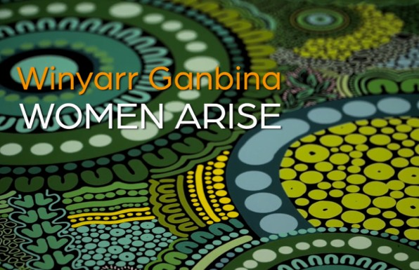
Resources to build welcoming and inclusive environments for people with disability with an emphasis on Indigenous women with disability

Involvement in sport is associated with mental, physical, and social benefits and positive community outcomes. However, not all community members are afforded opportunities to capitalise on these benefits. Notably, women, people with disability and Indigenous people are underrepresented in sport participation.
Sport organisations play a pivotal role to ensure greater inclusion for all community members
in their sport. To enable greater inclusion of community members, support is required for these organisations. To assist, the first of its kind resource in Australia has been developed to support sport and school environments build accessibility of sport to Indigenous women with
disability and people more broadly with disability.
Victoria University has partnered with Outback Academy Australia (OAA) and Paralympics Australia on this ground-breaking Australian Government Department for Social Services project. Winyarr Ganbina (Women Arise) short films and the OAA Red Dust Heeler checklist form this unique resource. The short films feature the lived experience and advice of Indigenous women with disability from across Australia, the checklist provides a list of recommendations based on lived experiences from the OAA Red Dust Heeler disability inclusion team.

6 Play By The Rules | Magazine Issue 40

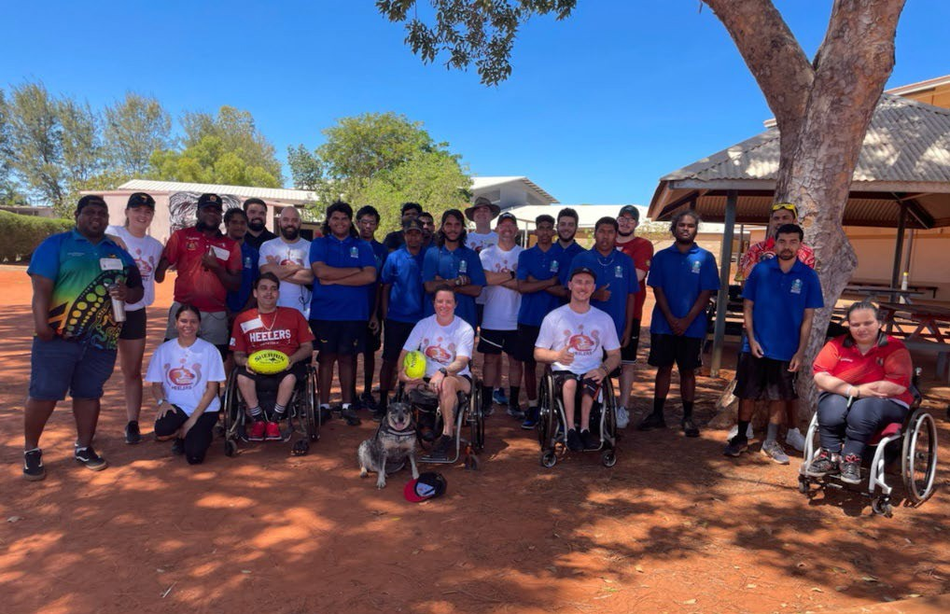
Winyarr Ganbina (Women Arise) short films
Indigenous production house, Typecast Entertainment produced the short films which include personal and empowering stories from eight Aboriginal and Torres Strait Islander women athletes. A Yarning Circle was also established
to gather the voice of these women in regards to their experience playing sport. Nine short films have been produced. The first is a compilation of stories by the eight women, the remaining films are an extended version of each woman telling their journey in regards to participating in sport from an attraction and retention perspective.
OAA Red Dust Heelers Checklist
Developed by OAA’s Red Dust Heelers (disability inclusion team), 15 tips are provided in the checklist. The focus is to assist organisations build welcoming and inclusive community sport environments for people with disability with an emphasis on Indigenous people with disability to lead and play in sport.

The unique aspect of these resources
OAA Chairperson, Leanne Miller a Yorta Yorta woman and long-standing gender equity
advocate said: “Winyarr Ganbina captures the lived experience and views of Indigenous women with disability. Their voices encourage greater inclusion for all in sport. The checklist is based on the experiences of our Red Dust Heelers team members, some are Paralympians, and will be a solid guide to initiating greater engagement and inclusion in sport.”
The hope for these resources are that schools and community sports organisations will use the films and checklist to encourage and increase the participation of all people with disability in sport. In particular the emphasis is on Indigenous women with disability, a group significantly underrepresented in sport.
NB: These resources form part of a larger Australian government national project focused on building capacity of women with disability
to lead community sport organisations in their quest to embed inclusive practices for people with disability to play sport. The project is led by Victoria University (Professors Clare Hanlon and Tracy Taylor and Dr Kara Dadswell), in partnership with Outback Academy Australia and Paralympics Australia.

Play By The Rules | Magazine Issue 40 7

When you take on the role of a volunteer,

CLUB RESPECT TIPS FOR
THE VOLUNTEER
you are supporting your club and community.

You can choose how this power will impact people – for good or for bad.

Volunteers affect the club’s culture and add character and feeling to a club. However not all volunteers uphold the values of the club. You hear stories of volunteers who are hard to get along with, make sexist, racist or other demeaning comments and generally make others feel uneasy.

But we also hear stories of volunteers who value teamwork, treat people with respect and openness and enjoy the company of others. It’s your choice.

Volunteers are the lifeblood of the club. It’s what gives community sport meaning.

The following page is an excerpt of practical tips from the Club Respect website.
Find more videos, how-tos and other resources for you and your club:

LEARN MORE clubrespect.org.au

hello@clubrespect.org.au | (03) 9642 0422 | www.clubrespect.org.au | © Club Respect 2021

8 Play By The Rules | Magazine Issue 40

Alignment of values
A
Effective
Communication
E
Ownership
O
M
Modelling Respect
Equality and Fairness
E
S
Success judged (the right way!)
W
Working well with others

You and your fellow committee members must live and breathe the stated values of the club.
- Check the club’s mission and values statements and Code of Conduct. Understand them for their real meaning and what these require of you.
- If you don’t want to be part of this mix, then move on. Don’t waste your time and the time of others.

Lead by example in the way you work with people.
- Be kind and fair.
- Safely and calmly challenge other volunteers who treat people disrespectfully.
- Take issues of bad behaviour to the club committee for resolution.
- Resist the temptation to gossip and undermine others around you.

Your communication with others will always impact the culture of the club.
- Listen and absorb the views of others.
- Speak respectfully to those around you.
- Support your team without being abusive.
- Do no abuse opposition players and spectators. Ever.
te abuse opposition players and spectators. Ever.
- Demonstrate respect for referees and lines people.

You’re part of the mix in determining how success is measured and judged at your club.
- If you’re happy with the club’s success measures, then do your bit in translating them into practice. For example, helping to celebrate the achievements and milestones of players and others around the club.
- If you think that there’s too much emphasis on winning at all costs at the expense of other measures, then raise this constructively with the right people. A polite conversation with a committee member is a good place to start.

Accept that your role adds to club culture. Take an active part in building a respectful culture.
- Check your words and deeds against the expectations of the club.
- Acknowledge and credit others for their contribution to the club’s positive culture.
- Politely and kindly remind other volunteers about club values and expectations.
- Raise issues of bad and unacceptable behaviour with the right people at the club.

The more people who model strong and respectful behaviour around the club, the better.
- Watch your own language.
- Behave with respect and fairness in mind all the time.
- Embrace diversity and welcome all newcomers.
- Call out disrespect or inequality.

Everyone should be treated the same way and enjoy the same access to the assets at your club.
- You have every right to step back and observe how things work in your club.
- If you see instances of unfairness, such as the unequal allocation of club assets, draw these to your committee’s attention.
- If you have ideas for improving fairness and equality at the club, don’t hesitate to outline and promote these with those around you and to the club committee.
- If you feel the club can do more to be genuinely welcoming of different backgrounds, then raise this for constructive resolution within the club.

hello@clubrespect.org.au | (03) 9642 0422 | www.clubrespect.org.au | © Club Respect 2021

Play By The Rules | Magazine Issue 40 9

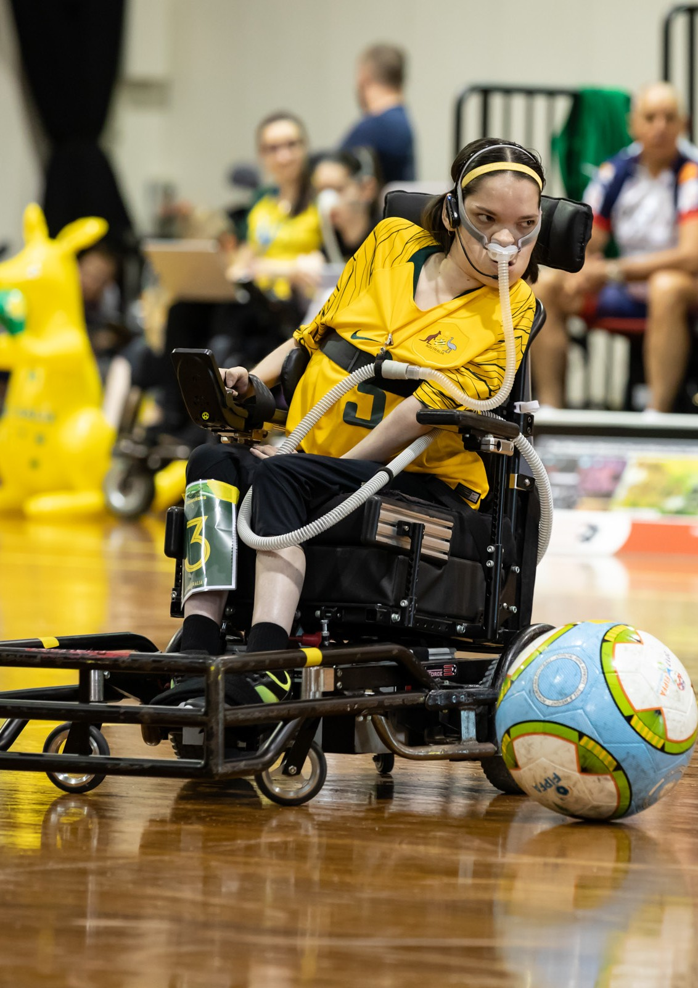

10
KG

10 Play By The Rules | Magazine Issue 40

Rebecca’s Story – Life as a Powerchair Football Athlete

As the result of a physical disability, I use a power wheelchair and ventilator. Growing up, ‘athlete’ was never something I could identify as. But when I was introduced to powerchair football in 2018, being an athlete became my major life passion.
In a nutshell, powerchair football – or soccer, for those who don’t believe football can be anything but AFL – is a form of football played by athletes who use power wheelchairs. In teams of 4 on a basketball court, athletes use a specialised sports powerchair to dribble, pass and ‘spin-kick’ the ball. As a competitive person who enjoyed being able to compete independently, I took to the sport like a duck to water.

If it weren’t for powerchair football and meeting these athletes, my independence story would look very different.
After just under a year of playing, I competed in my first national tournament. It was here
that my passion for the sport was really ignited. I saw the quality of the other teams and was able to meet powerchair athletes from across Australia. This point is pertinent. If it weren’t for
powerchair football and meeting these athletes, my independence story would look very different.
It was through these athletes that I learnt about Specialist Disability Accommodation (SDA). They explained that SDA is for people like me on the NDIS who have high physical support needs .
They told me stories of increased independence, sporting opportunities, and social and community engagement. Where I was once convinced I would never move out of my family home, I then made it my mission to also achieve the same.
I applied for SDA in mid-2020, with my heart set on a Perth CBD apartment. It would place me close to sport and allow increased social opportunities with fellow athletes. Although I was approved for SDA
in late-2020, the pandemic wreaked havoc on the building sector, and the Perth CBD development was delayed.
Fast-forward to early 2022, and I was still not living in SDA. The Perth CBD project had been paused, and powerchair football in WA had ground to a halt. It was then that I decided to relocate to Melbourne. Not only do they have an amazing powerchair football league and the opportunity to train under an Australian National Team Coach, but it would be easy enough to drive up to Sydney where I regularly attend training camps for the Australian team.
So I applied for and was accepted for an SDA apartment in Melbourne’s Docklands – the perfect location!
An SDA apartment in Docklands is the springboard I needed to get back to my passion of playing powerchair sports, competitively. Despite not having moved yet, I’m already seeing the benefits, with an Australian national coach telling me
that my move to Melbourne will give me the best chance to compete for Australia – a major dream of mine.

This is an edited extract. Read Rebecca’s full story and find out more about SDA at https://www.housinghub.org.au/resources/
article/kicking-goals

About the author

Rebecca is the Housing Hub’s Lived Experience Team Coordinator. Rebecca has a Bachelor of Psychology (Honours) from Curtin University.
Rebecca has Specialist Disability Accommodation (SDA) funding in her NDIS plan and is currently planning a move from Perth to Melbourne, where she has been approved for a High Physical Support SDA apartment.
Rebecca is passionate about advocating for people with disabilities and ensuring they have access to the information they need to live their best life, particularly regarding housing and the NDIS.

Play By The Rules | Magazine Issue 40 11

In 2020, the Australian Human Rights Commission published the landmark Respect@Work report, which made some 55 recommendations to strengthen laws and requirements to help prevent sexual harassment and discrimination in the workplace.

Positive duty to eliminate sexual harassment and discrimination
New federal government adopts key
Respect@Work recommendation
One of the most significant recommendations was to amend the federal Sex Discrimination Act to introduce a ‘positive duty’ on all employers to take reasonable and proportional measures to eliminate, sexual harassment, discrimination and victimisation.
The positive duty wasn’t adopted by the previous Coalition government, although some of the other recommendations were. However, Anthony
Albanese made a clear pre-election commitment to fully implement all recommendations, in particular the positive duty, and it’s likely that the new government will soon move to make the necessary amendments to the Sex Discrimination Act.

How is the positive duty different to employers’ current obligations?
Currently, the federal laws (and most state laws) don’t impose any obligation on employers to take ‘pro-active’ steps to stop sexual harassment,

discrimination and victimisation. Instead, it’s mainly a reactive system in that an employer can be held to be liable for individual acts of sexual harassment or discrimination committed by employees – unless the employer can prove it took reasonable steps to prevent it, such as having records of employee training.
As recognised by the Respect@Work report, most people who experience sexual harassment don’t report or make complaints about it due to the potential impact on their reputations, career
prospects and relationships with their community or industry – and this means a system focussed on individual employees making complaints is not fit for purpose.

What will need to be done to comply with the duty?
At this stage, the government hasn’t introduced detailed legislation and regulations explaining the practical steps and action needed to comply with the duty. The Respect@Work report notes that in determining whether a measure to eliminate sexual harassment, discrimination and victimisation is ‘reasonable and proportionate’, the new legislation should set out the factors to be considered, including:

12 Play By The Rules | Magazine Issue 40

- the size of the person’s business or operations
- the nature and circumstances of the person’s business or operations
- the person’s resources
- the person’s business and operational priorities
- the practicability and the cost of the measures
- all other relevant facts and circumstances
This means that the practical requirements should ideally be proportionate, rather than a one size
fits all duty for all employers ranging from large corporates employing thousands of people to very small businesses and organisations.
Victoria’s situation is instructive – since 2010, the state has had its own local legislation with a similar positive duty, so some employers will be familiar with the obligation. The Victorian Equal Opportunity and Human Rights Commission provides some examples of how sports clubs can comply with the duty given their size and resources, including preparing an action plan,
putting in place (and regularly reviewing) clear and
practical policies and procedures for issues to be raised. Some employers in Victoria also have in their employment agreements a clear statement explaining the duty and each employee is expected to support the employer in complying with it.
Hopefully, the Albanese government will soon start providing practical guidance on how smaller employers and organisations can comply with the new duty.
While some may fear the change is more red tape, compliance with the duty will not only satisfy obligations under discrimination laws, but will also go towards complying with WHS obligations to manage risks and ensure the safety of employees and ultimately, will help drive productivity across all workplaces.

Chris Hill
Principal Solicitor
Stadium Legal – Employment and Commercial Law
0498 881 069
chrishill@stadiumlegal.com.au www.stadiumlegal.com.au

Play By The Rules | Magazine Issue 40 13

Global resistance to referee abuse: Officially Human (U.S.A.)

Patrick Skene & Brenda Hilton

The unchecked behaviour of players, coaches and spectators towards referees creates an unsafe environment and reduces the enjoyment of everyone involved. Advocates for the respect of referees can be found all around the world.

Brenda Hilton of Officially Human shares insights on the challenges faced by Referees and Umpires from the U.S.A. Brenda is trying to make the world a better place and trying to do it one official at a time.

Thanks to Patrick Skene (who has written in-depth on the impact of referee abuse across various sports in Australia) you can listen to the full interview and read along with the following transcript.

Club Respect.
Pass It On.

Originally published on the Club Respect website and republished with permission from Club Respect

14

Introduction: Brenda and Patrick [0:00]
Patrick Skene
In today’s episode of Club Respect, we meet Brenda Hilton, the founder and CEO of ‘Officially Human’ whose mission is to restore respect to and generate positive treatment of sports officials and recognize them as authorities on the fields and courts. It’s great to catch a thought leader in the space and we have one joining us from Chicago. Hi, Brenda.
Brenda Hilton
Hi there. Thank you so much for having me on here. I know that we’re in different parts of the world but we all serve the same common mission.

Officially Human background [0:31]
Patrick Skene
Officially Human – what a wonderful name.
Brenda Hilton
Thank you. Now there’s a little bit of a debate inside the Hilton four walls as to where the name came from, but I do have to give my husband credit because I had something like humanly official and the person behind the stripes. And so he said, ‘Well, we’re not officially human’ and so he worked on that and the logo.
Interview Transcript:
Patrick Skene chats with Brenda Hilton

Contents
- Introduction: Brenda and Patrick [0:00]
- Officially Human background [0:31]
- The Problem: Youth sport parent and coach behaviour [1:58]
- Officially Human Focus [2:55]
- Youth sport referee crisis [3:28]
- Abuse at Youth Sports: an uncomfortable topic [5:46]
- The impact of Covid on Parent behaviour [6:50]
- Does the competitive nature of American society create ‘ugly parent syndrome’? [8:04]
- Key findings of Officially Human’s big survey on referee abuse [9:24]
- Self Sabotage is leading to a tipping point [11:18]
- Officially Human Brilliant TV on parent abuse [13:02]
- The negative impact of Media and Gambling [13:58]
- Big Tournament Syndrome [15:00]
- Worst American sports for referee abuse [16:22]
- Officially Human’s ‘Elevate Respect’ Program [18:35]
- Why isn’t referee abuse a workplace and bullying issue? [21:22]
- Mental health issues with referees [23:12]
- The impact of social media [24:21]
- Could government legislation be a solution? [25:12]
- Thoughts on Body Cams as an option to capture referee abuse? [26:24]
- What’s going to turn the tide? [27:04]
- The Officially Human Elevator Pitch [28:49]
Patrick Skene
That’s great. Tell us how you came to create it. And what did you see, what were your trigger points?
Brenda Hilton
So I started in collegiate athletics. I want to make sure the audience knows that I have never ever (refereed) or worn a set of stripes except for one time at a Halloween party. So, I was really intrigued with everything that went into officiating, from how the assignors found officials, how they recruited them, how they retain them, how they train them.
And over the years, I just watched and heard horror stories of the treatment getting worse and worse and worse. And one day in 2019, I was sitting at my kitchen table, and I wrote a business plan. It was really bad, but I came back the next day and told my husband what I was thinking about doing and I’ll be honest with you, Patrick, I haven’t had one person tell me I’m crazy. So, the need is there. The attention is growing. So if there’s a problem, you can run from or you can run to it.

The Problem: Youth sport parent and coach behaviour [1:58]
Patrick Skene
Yes, I couldn’t agree more. And you don’t have to go further than social media to see the problem you’re trying to solve.
Brenda Hilton
The other interesting thing that I talk about a lot, is 95% of these competitions go on without any incident. However, it’s that 5% that is so incredibly
dangerous to and detrimental to youth, high school and college sports. Of course, you don’t have those problems as much at the high school and pro levels, but these behaviors are being learned at a very young age.
In youth sports – this is where (the bad behaviour) is being learned. And that’s where so much of the focus for ‘Officially Human’ is. In getting to youth organizations and getting them to understand that if we can just spread a message and let everybody know, educate people, what is really going on and how detrimental it is to our youth for years to come. Then we’re going to do something right.

Play By The Rules | Magazine Issue 40 15

Officially Human Focus [2:55]
Patrick Skene
So what would you say is ‘Officially Human’s focus?
Brenda Hilton
The focus is to educate, bring awareness to parents at the youth and high school level, to get them to understand that this is a global problem. And if
we don’t start to turn this treatment around and respect everybody, not just officials but respect everybody, these competitions are going to go away. The number of competitions are far greater than the number of officials available.

Youth sport referee crisis [3:28]
Patrick Skene
It’s a worldwide crisis. Now I went through the last year of your social media and it was a pretty sobering scroll. There’s so many disturbing stories on there. In Nebraska, a baseball catcher deliberately moves and steps aside so a fastball
pitch hits an umpire. In Iowa, an official is assaulted by a fan at a 3-on-3 tournament and child referees are getting accosted in parking lots.
Massachusetts hockey is complaining about a severe referee shortage, yet one official needed a police escort after a game featuring eight-year- olds.
So you’ve got three factors – the pandemic, low pay, and abuse, both verbal and physical which has triggered an exodus of referees from youth sports.
There are referee shortages across the nation. Registrations are down. Refs are becoming an endangered species. Is there a bigger crisis in American sports?
Brenda Hilton
I think there’s a big crisis around the world. We are just not a very nice society right now. I think
that’s one of the bigger things that I think ‘Officially Human’ would like to factor in, is let’s think about all of our actions before we do them.
I was on a call this morning with an organization out of North Carolina and we were talking about what happens if 95% of people in an arena
are really good, and we remove that 5%, the environment is so much better. How do we get organizations to have what it takes to remove these people?
What is the penalty going to be for these people?
The group that you were talking about at the baseball game where the catcher moved out of the way. That team has been suspended for the rest of the tournament and they can’t participate in any more of that organization’s tournaments.
Other organizers have reached out to that group to say hey, who is this? We’re not gonna allow them at our tournaments either.
But Patrick, you and I are smart enough to know, that all they have to do is put somebody else’s name on the roster, and that coach can still be there.
So, it’s really trying to get people to understand, okay, this is a problem. We have to start talking about it.

Abuse at Youth Sports: an uncomfortable topic [5:46]
Patrick Skene
‘You can’t solve if you don’t talk about’ it is a fundamental across the world for abuse of match officials. It’s this black spot that’s hard to get people talking about.
Brenda Hilton
Well, I presented at a consortium this week, and my topic was ‘We have to do better’.
And when I went up on stage, I said, all right. I just want everybody in the room to know that I might offend some of you and I just want you to leave this room and I want you to think, and I don’t want you to get mad at me. But I really want to provoke thinking here. And when I say this:
‘Would any of you in this room work for the same game fee for six years? Six years!’
We want people to work for the same pay yet everything around us is going up in cost. You know, our kids get older, they get more expensive. That’s number one.
Number two, do we have to look holistically at the assigning process (better behaved clubs getting access to the scarce referees) and maybe we need to blow this thing up and that’s hard because people don’t want to have this conversation. They just don’t want to have those conversations.

The impact of Covid on Parent behaviour [6:50]
Brenda Hilton
So during the pandemic, I did quite a few podcasts. I have my own theory and I could be completely wrong. But I think that the pandemic did more harm to so many people and I talked about that, say you have a mom and dad who may not necessarily agree. One of them wants their child to play and the other doesn’t. They’ve lost one to two years of competition.
So, parents now think that when they go to these youth events, it is ‘live or die’, that the collegiate scholarship is on the line for an Under 10 baseball

16 Play By The Rules | Magazine Issue 40

game. And now we’ve got mom and dad arguing and what happens? Who are they going to take their frustrations out on? It’s going to be the umpire every single time.
Patrick Skene
It’s an interesting theory, the pandemic one (worsening parent behaviour). It’s happened across all the sports down here, where I would naturally think that parents would be more appreciative of something that was taken away. But I haven’t really seen any of that. I’ve seen a lot of angst projected and doing a sport by sport analysis, we’ve seen the same thing.

Does the competitive nature of American society create ‘ugly parent syndrome’? [8:04]
Patrick Skene
I’m really interested because we look at America as the peak of competitive sport in the world. I remember Nike’s motto for the Atlanta Olympics was ‘You don’t win silver, you lose gold’
Culturally, we look at America as the peak of competitiveness. Is there anything cultural there relating to American parents who (outside of sport) are in a dog-eat-dog world?
To make it to the top in America in any key industry, you have to have come through an incredible pathway – to become great in music or to become a great lawyer is tough and at grassroots level, does that competitive spirit overflow to the parents?
Brenda Hilton
In my humble opinion it does. I will be the first to admit that when our son was in high school, and you go to these AAU games and you watch these people, and sometimes I would even get caught up in it. And then I’m like, wait a second.
If my child is going to play in college it is because of what he does, the work he does on the court.
I can’t do that for him and that’s gotten lost, and everybody you talk to says: ‘we’re all living for our kids now.’
However, we’re actually doing so much damage, because we’re putting such immense pressure on these kids.
And then the other thing I think about is just because you paid a fee for your child to be on a team does not give you the right to berate coaches, other parents and especially the officials.
But somehow, people think they have a right to do that.

Key findings of Officially Human’s big survey on referee abuse [9:24]
Patrick Skene
So you’ve done some wonderful research.
‘Officially Human’ conducted a survey in 2019 of officials in 15 states, in all sports at the high school level and below. A big sample size was what I liked, almost 19,000 respondents.
What were the highlights of that study?
Brenda Hilton
There’s a couple of glaring things that we really want people to focus on. Firstly, people don’t realize that 70% of our respondents do officiating for the love of the game. And that gets so lost.
The second stat is that 55% of referees were over the age of 55. Well, that group is now 58.
The most glaring stat to me is that only 12% of those 19,000 referees surveyed are under the age of 34. So we have so, so much work to do. And that was pre-pandemic. We don’t know how many of those didn’t come back.
The other interesting thing was that when we started writing the questions for this survey, we didn’t know what the response rate would be. We had no idea. And I’m kind of a freak, so I was sitting here and we would send out a survey to a state and I would just watch on Survey Monkey. And watch these results come in.
What do you do with 19,000 responses?
Well, you surround yourself with really smart people who can break down the data. Probably the biggest thing out of all of it though is those officials wanted a voice. They wanted a voice. You don’t get 19,000 responses because they’re bored. Because it was 53 questions.
Isn’t it funny how long it takes for survey data to get attention, but it’s really starting to get more attention now.
Patrick Skene
I’m really interested in why officials leave and the top two reasons is verbal abuse from fans and coaches. It was more than 50% for those surveyed and you’ve clearly got data on the problem.

Play By The Rules | Magazine Issue 40 17

Self Sabotage is leading to a tipping point [11:18]
Patrick Skene
Why do we have this level of aggression that we can’t see that you can’t play, without referees? Your kid won’t be able to play without this essential service that’s being provided to your kids. What is it in us that is so self-sabotaging?
Brenda Hilton
I think all of us are competitive in nature. Keep in mind, probably 95% of the people are pretty good people. But if you have a game of three basketball officials, and there’s a couple of fans that just won’t leave them alone, and you lose one of those officials. To your point (the tipping point) it’s coming.
But the reality is, games are now getting canceled a lot in the United States. So teams are going to start not being able to participate in these big tournaments because there’s just not going to be officials.
And I think we’re probably still a couple years away from this really happening at scale. It’s coming. And what’s going to happen is people all of a sudden are going to say: ‘Well wait a second, why can’t we play this weekend?’
A couple of weeks ago I was talking to the head of officiating for the Louisiana High School Association. And he said that his top assignor for their most competitive baseball, makes eight to 10 calls a week and half of those calls are to head coaches saying ‘you can’t play a baseball game tomorrow because I don’t have umpires for you’.
And the other half is ‘you can only play with one umpire’. So now we’re putting one umpire on a field by him or herself. And that risk (of errors and abuse) is even greater.

Officially Human Brilliant TV on parent abuse [13:02]
Patrick Skene
I want to congratulate you, you’ve created a wonderful, clever ad. It’s the best I’ve seen trying to create empathy for match officials. The ad has people standing up in a music recital and abusing the kids that are playing the instruments and the conductor just like they would in a sporting field, but in it’s in a quiet, alternate environment.
What a beautiful ad to build empathy about how ridiculous these parents sound. And it raises the question – why is the sporting field a unique place where abuse is permissible?

Brenda Hilton
That’s a great question. And when I have the answer to it, I hope I’m a millionaire.
And the other problem is… what are we teaching our youth when we are so upset at a game that we are arguing with the people around us, we’re arguing over a call at an Under 9 baseball game. In what planet are we living?
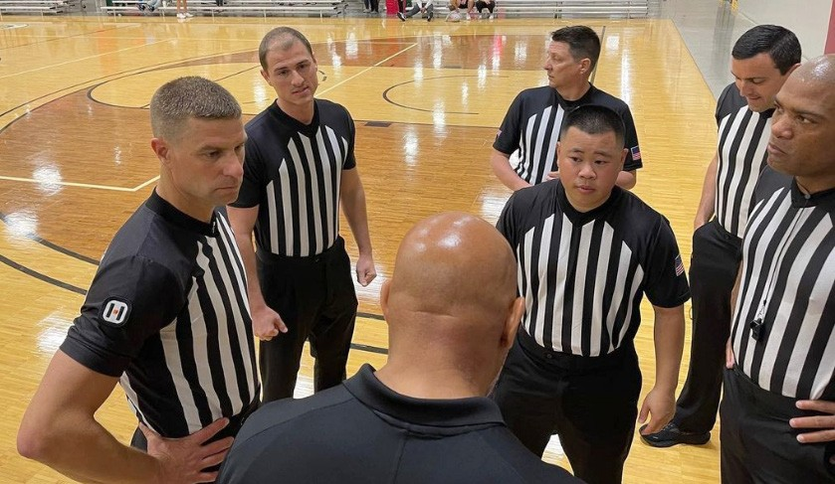

The negative impact of Media and Gambling [13:58]
Brenda Hilton
I think the other thing that has to be talked about and it’s kind of the elephant in the room is our media. Media doesn’t necessarily help us when they are on TV, and they’ve got 14 different views of one play.
And they can over-scrutinize these officials when they say their names on national TV, and I’m talking at the collegiate level. And next thing you know, you know, there’s been death threats against collegiate officials. It’s terrible.
Patrick Skene
And then at the pro level, you’ve got people gambling and losing money.
Brenda Hilton
Well, now you can gamble at the collegiate level.
Patrick Skene
So because of that you’ve got extra angry people, who believe the referee had an outcome in them losing $20,000, $50,000 $100,000, $500,000 dollars.
Brenda Hilton
Right. The other thing I think about a lot is: when did it become so incredibly competitive that we forgot about the social aspect. Where did that get lost in all of this? We can’t even lose gracefully now. We don’t want anybody to lose.

18 Play By The Rules | Magazine Issue 40

Big Tournament Syndrome [15:00]
Brenda Hilton
We’re attending a softball tournament at the end of June. There’s 1100 teams registered for this softball tournament. And when you think about that, there’s going to be a winner and loser at every single game. That’s what it is.
And so, if you’re losing 15 to 1 and you get mad over a call, and you ruin the next two games for your kids because you’ve embarrassed yourself or maybe your team gets kicked out. This is what we’re doing.
And this is real stuff, this happens. So when we go to this tournament, I’m going to have the opportunity to talk to all the coaches in the room and talking to all the game managers about all of this. Just (tell them to) take a step back.
Patrick Skene
I think more than captains, coaches (in this situation) are the most important because the coach is the only one that has any sway over an errant parent. Would you agree?
Brenda Hilton
I would, however, it’s really hard. Because if a parent is paying US$1,000 for their kid, they’ve tried out for this travel team and they’ve made the team. They think they have a right to tell the coach what to do. So, it’s hard and it’s a big problem on every single level.
In hockey over here, we have a friend that pays between US$12,000 to $15,000 a year for their child to play hockey. It’s insane. It’s crazy.

Worst American sports for referee abuse [16:22]
Patrick Skene
I’m interested on a sport-by-sport basis, what are the unique things about Hockey, Basketball,
Baseball, American football and Soccer. Who’s the real problem child (for referee abuse)?
Brenda Hilton
I don’t have hard facts on this. I just have my experience. I would say that Baseball is really, really, really hard. And the theory behind that from my experts in the field is the time between pitches and the proximity, you can get right up and stand at the fence and yell and scream at the umpire.
Basketball, I hear a lot about that because the bleachers are right on the floor. So some of the smaller gymnasiums, you don’t have a lot of space. Sometimes you’re tripping over people to get down the sidelines of a basketball court.
(American) football fans are just, very, very intense. But I don’t see those abuse cases as much as I do

as in basketball and baseball.
Soccer seems to be worse overseas than it is here.
Patrick Skene
Would you say that the culture in baseball when the coach leaves the dugout and there is chesty shouting at the umpire which seems to be putting people on the verge of a physical fight when you’re in each others face shouting as loudly as you can, do you think that contributes in baseball as well?
Yes, absolutely. There’s an organization down in Indianapolis, and at their baseball tournaments they actually painted a circle outside of the dugout. Where if a parent has a question on a call, they have to go to that circle and then somebody from game management will eventually get there and answer that question.
That has seemed to help them a little bit, but not a lot.
The thing right now though and I worry about this, is when you talk about this officiating shortage in all these sports – What’s going to happen when we start elevating people to games they’re not ready to work, because we don’t have the people to work?
That’s going to just cause another layer of anger with parents.
There’s gonna be lower quality officiating. Because you’ve just got less people in the pool.
Brenda Hilton
Yes.

Officially Human’s ‘Elevate Respect’ Program [18:35]
Patrick Skene
You’ve got an online program called ‘Elevate Respect’, which is an online education series with short lessons for parents and fans to go through. Clubs can register for that program. Tell us about Elevate Respect and the wins and how that’s going.
Brenda Hilton
So the program consists of six mini lessons. It takes two to three minutes to go through each one. It is not narrated on purpose, because we want people to engage in the program. So, it walks you through the sport ecosystem, and in various areas.
One area is the treatment of officials. What’s the consequences when you go up to a soccer
referee, that’s 12 years old and yell and scream at them? What’s going to happen if we don’t get more referees and officials in the game?
One section talks about everybody’s role, what is your role? What’s a parent role? What’s the fan role?

Play By The Rules | Magazine Issue 40 19

What’s the administrator’s role?
If an organization signs up, we want (at least) 50% of their parents to go through the course and then that organization is considered ‘Officially Human Certified,’ and they can hang banners and can hand out things. But really, it’s an awareness campaign to get people to understand that this is what is really going on in the world of youth sports.
We were intentional when we went to pilot this. We have some friends that might not necessarily have always been nice to officials. And we gave everybody that piloted the program the chance to give us feedback. This feedback from this person said: ‘I’m appalled at the way I act. I had no idea how I was affecting youth sports.’
That person is now a champion for ‘Officially Human’. So, it’s going to be one person at a time.
We have to go through IT and cybersecurity training. We have to go through sexual harassment training, a lot of coaches have to go through concussion training. We see this program as another element of training.
Patrick Skene
Respect training.
Brenda Hilton
Yes. I always have this notion that I want to be in your face without really being in your face. I want you to go through this program and I just want you to absorb it.
We did it on purpose that it’s not a push-and-play program because I’ve worked with NCAA coaches long enough. I know what they do to those videos, they hit play and they walk away.
So we were intentional in the way we did it.
We wanted to be engaging and there are some questions on there that you have to answer. It’s not a pass or fail (scenario). Everybody passes.

And then we have basketball rules and baseball rules that we put together – just a list of 10 of the most common misunderstood rules.

Why isn’t referee abuse a workplace and bullying issue? [21:22]
Patrick Skene
There’s a universal creed that no one should be abused at their workplace. So how is the abuse of referees not a workplace issue?
Brenda Hilton
That’s a great question, Patrick. That is a great question that we try to wrap our arms around every day. And not only that, we’re abusing 12 to 18 year olds, forget the adults, its 12 to 18 year olds that
are trying to make a little extra money. And they’ll leave. 80% (of referees) leave in the first two years. 80%!
Patrick Skene
So what makes adults abuse of child referees not bullying, when everywhere else bullying is being amplified (and punished). Why isn’t that seen as bullying?
Brenda Hilton
Well, I think a lot of it is, ‘How do you manage it’?
Is it because (for example) you’re at a tournament in Des Moines, Iowa. You go to a tournament, you bully somebody, but then you go back to Missouri to your home.
It was 2019, I don’t know if it was Nike or Adidas, one of their high level AAU basketball tournaments, they actually had bouncers on every single court.
But not every tournament is going to invest that money in that.
So, they would rather take the chance and gamble on not having any incidents and save that money. Well, I think a lot of this truly comes down to money. We have talked to several organizations across the world about ‘Elevate Respect’, and there’s a lot of times it comes down to money.
In the workplace we have to be very, very careful, everything we say now but as soon as you get to a competition you can say whatever you want, it
doesn’t matter how many kids are around, you can swear as much as you want and for what?

Mental health issues with referees [23:12]
Patrick Skene
In Australia, mental health is starting to rear its head among referees. That not only are people being abused and not feeling good, it’s actually crystallizing into mental health issues. How’s that playing out in America?

20 Play By The Rules | Magazine Issue 40

Brenda Hilton
I haven’t followed that quite as much. However, what I will say to that is, when we talk about mental health, and I heard this week, somebody said, let’s change mental health to mind health.
But what does it do to your child?
When your parent is always the person screaming at the officials and maybe other parents?
It’s such a global problem when we talk about mental and mind health that, I think for officials, they’ll just quit working. They’ll just stop officiating, it’s not worth the $25.
So for mental health, I don’t know if it’s quite as much because they will just leave. But I worry more about the kids that have to endure this every single day, every single weekend when they go to play.

The impact of social media [24:21]
Patrick Skene
There is also a more modern problem. People not abusing on the field, but abusing referees through social media.
Brenda Hilton
Well, I know that there’s a lot of organizations that tell their officials that they cannot be on social media because of that. And you think about it.
When I was in the basketball world, the officials would always say….the great thing about basketball, is there’s another game the next day.
However, for a sport like football where there’s only one game a week, that abuse can go on for a whole week until you get to the next game. So it depends on the number of games & competitions that that are going on.
But yes, it is a very serious problem as well and social media is just the devil for us.
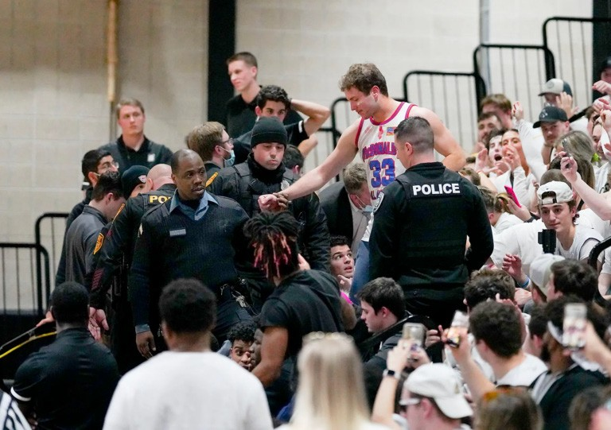

Play By The Rules | Magazine Issue 40

Could government legislation be a solution? [25:12]
Patrick Skene
I’d like to discuss government intervention (for the crisis). If the threat of an assault charge hasn’t deterred some people from attacking an official, maybe there needs to be laws and state
legislatures passing laws to protect officials. So it’s really got some teeth. Is there any talk about that?
Brenda Hilton
There are a few states that are talking about that. I think the problem or maybe the hurdle is often these abuses aren’t reported. So then that same
parent you know, can go to the next week and then do it to a different referee.
And what is really going to happen because if it takes six months, or two years for somebody to get charged and whatever their sentence is, then it’s like, ‘is that really helping us?’
Because if the person just has a charge pending, and they can still go to games. They still have access to the officials. Sometimes the officials don’t want to make a complaint, they just want it to go away.
Patrick Skene
And by prolonging it through a judiciary environment is only prolonging the pain. That’s a really interesting point.

Thoughts on Body Cams as an option to capture referee abuse? [26:24]
Patrick Skene
Body cameras. What are your thoughts? (referees wearing them to reduce referee abuse)
Is the debate happening that this may improve accountability and that these exchanges between players and referees are captured? What are your thoughts?
Brenda Hilton
I don’t have a great deal of knowledge on that other than what we do in in football.
When we talk about something like body cams, you think about the cost that it takes to have the technology. Are clubs really going to invest to have those antennas they need at their remote
locations. Maybe someday but I don’t know how it’s going to be in the next five years.

21

- What’s going to turn the tide? [27:04]
Patrick Skene
Is there anything out there that you can point to that’s getting traction in what you’re doing and what you’ve seen more broadly.
Brenda Hilton
The one thing I’m doing is I’m forcing conversation. I’m forcing uncomfortable conversations. I will talk to anybody that will talk to me about this subject to bring more light to it. And I also have a really good social media person. But just going to conferences and talking to people. Any athletic director I can talk to, any state association I can talk to, it’s creating the conversation and creating awareness.
There is a press release coming out this week that we just signed our first major partner, they are taking this problem very, very seriously. And we’re going to do some good things with them. And most of it is an awareness building campaign.
Patrick Skene
Is there a silver bullet that will move the needle?
Brenda Hilton
Public Service Announcements (PSAs) are great, but they’re 30 seconds and they go away. So in my perfect world, I would not only have ‘Elevate Respect,’ I would have some other online learning tools that people have to go through.
And I would have the ‘Officially Human’ logo everywhere.
‘We are an ‘Officially Human’ certified gym gymnasium’. ‘We are an ‘Officially Human’ organization, we believe in the positive treatment of officials and everybody around you.’
‘We take this seriously.’

You can say that unruly fans will be removed but if you don’t remove them on the first time, they’re just going to know that they can keep acting like that.
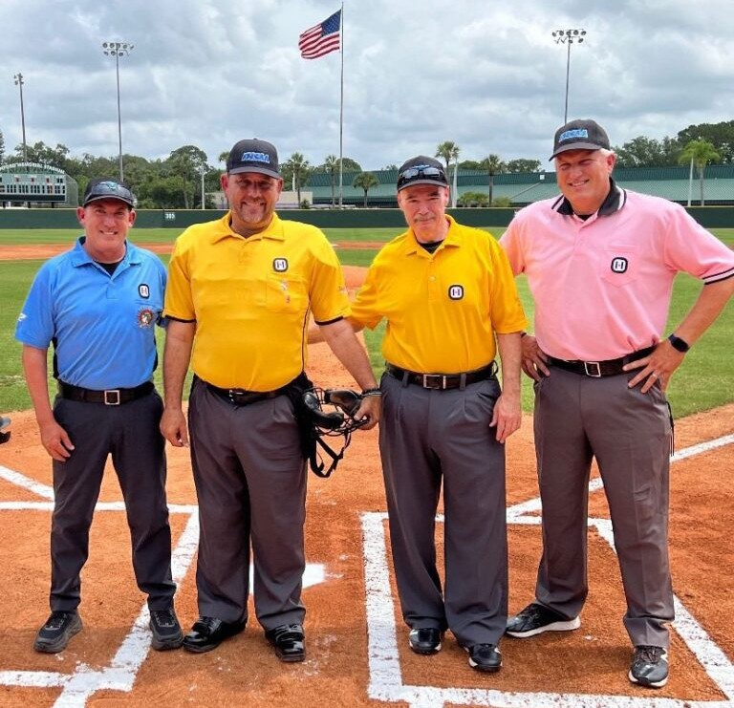But awareness, awareness, awareness, I want it to be in your face without being in your face.

The Officially Human Elevator Pitch [28:49]
Patrick Skene
That’s a good strategy. So I’ve read online where there’s lots of good feedback about presentations that you give.
I’d love you to give me the opening statement of a presentation when you’ve got a bunch of people in there who don’t think there’s a problem or don’t
think this is a priority. You’ve got to win people over in that first minute. Hit me with what you would say to them.
Brenda Hilton
Awesome. Good afternoon. My name is Brenda Hilton with ‘Officially Human’. I founded ‘Officially Human’ to humanise sport officials across the nation and around the world.
Those of you in this room, if you don’t understand or know that there is a problem with the shortage of officials, I’m here to tell you that it is very real.
Someday, one day in the very near future you are going to go to one of your child’s competitions. And you will be short of referees. You may be short one, or you may not have a competition.
I’m telling you it’s real. I’m in this space. I’ve been in it for 22 years. It is a real problem. And I want everybody in this room to think about it and think about solutions.
Patrick Skene
What an amazing pitch. Thank you so much for your time. And congratulations on a fantastic job. You’re doing wonderful stuff. Thank you.
Brenda Hilton
Thank you. All right, we’ll stay in touch.

22 Play By The Rules | Magazine Issue 40

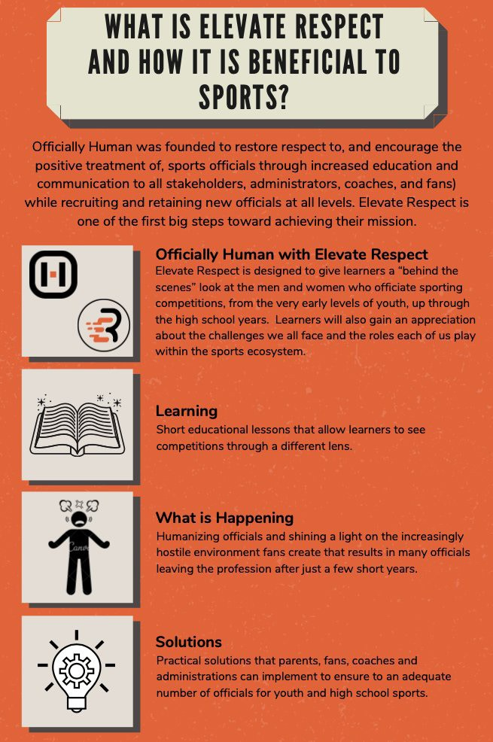

Play By The Rules | Magazine Issue 40 23

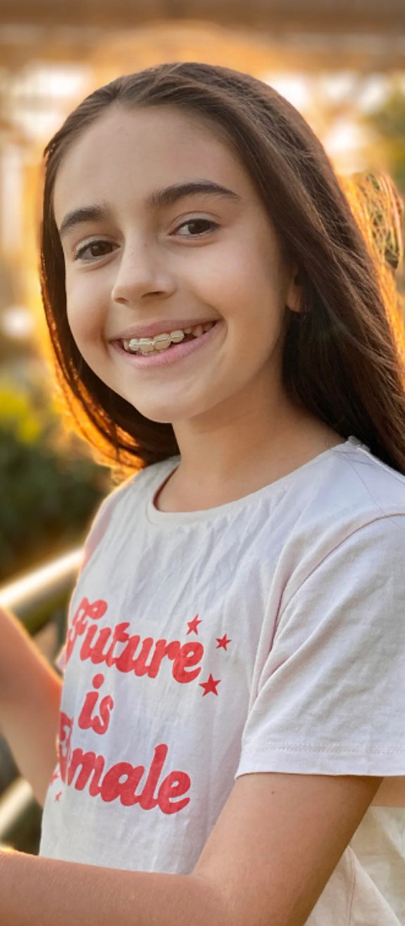

Her Way–
A young sports fan makes her own path
Abbie is the 12 year old creative behind the recently established HER WAY magazine, a monthly publication that covers
everything you’d want to know about Australian women’s sport. We reached out to ask a few questions to get an insight into her motivations and the values that drive her work.

Play By The Rules | Magazine Issue 40
24

What kinds of stories do you like to publish in HER WAY the most?
I really like interviewing athletes from a range of sports. It’s really great to see how different people can answer the same question in such varied ways. There’s also a regular segment called ‘Yest-Her- Day’s Hero’, where I research a pioneer or forgotten legend of a sport. I find that really fascinating too.

Who has been your favourite sportsperson to interview so far?
It’s so hard to pick a favourite. I often joke to my parents after an interview with someone that they’re my new favourite. But I definitely have a soft spot for athletes like Madison de Rozario, Cate Campbell and Ellie Cole. I’ve interviewed rising basketball star Jade Melbourne and Winter Olympian Britt Cox twice each and they’ve been huge supporters too.

Who is the ideal HER WAY reader?
When I started HER WAY, I guess the thinking behind it was that it was for girls. And while that’s still the case, I have a lot of subscribers who are adults, both women and men, which is pretty surreal. I have received emails and messages from 11yr old right up to 50yr olds. So while I definitely hope kids enjoy it, I try to write in a way that adults almost forget it’s been done by a kid.

Do you think the magazine has helped young girls find their passion for sport?
I definitely have received messages from girls, teens and even women in their twenties, telling me that HER WAY has helped them discover or appreciate sports they hadn’t really understood or
followed before. Those kind of messages make it all worthwhile.

What do you think HER WAY will look like when you’re 20?
I honestly have no idea. I don’t even know what it will look like when I’m 13! Media constantly changes and evolves, so whatever I do, I need to
make sure it’s a product the readers what, not just what I want to do.

Do you prefer to play sport or be a spectator?
I love trying a whole lot of sports. As I’m getting older, I can definitely stay focussed watching games more than perhaps when I was little. But
playing a team sport particularly is probably more fun because you make friends and share something together.

Are you involved in community sport?
I’ve been playing Aussie Rules for three seasons now. I also started playing cricket in a team last season, although we didn’t get to play too many games because of covid and bad weather. I like playing a few other sports for fun too such as basketball, and HER WAY has made me appreciate and enjoy netball - I’m thinking about joining a team.

What’s the kindest thing you’ve seen on the sidelines?
Hmm. I can’t think of a specific one, but one thing you see a lot in women’s sport is at the end of matches. It doesn’t matter what sport it is, and whether they win or lose, players will stay behind and sign photos and take selfies with young girls. That stuff really makes a difference. I know it made a difference to me when I was just discovering women’s sport.

What makes a positive culture in a sports club?
I think just knowing that, particularly in community sport, winning isn’t everything. Encouraging each player to develop and get better in a helpful way, and of course making sure they are enjoying it, is more important than winning at all costs.

What would you like to see more of in women’s sport?
Oh my gosh there are so many things I’d like to see more of in women’s sport! How long do you have lol? More money, more facilities, more exposure on TV, more reporting on TV news, websites,
radio. Often in clubs the female teams are an afterthought, they have to use boys toilets, they have to wear uniforms that were designed with boys in mind, or can only train when the boys teams aren’t there, or they have to play on Sundays because the boys get to play on Saturday. It’s great things are starting to change, but we can always move faster!

You can read more about Her Way and sign up for a subscription at the magazine’s website:
https://her-way-magazine.square.site/

Play By The Rules | Magazine Issue 40 25

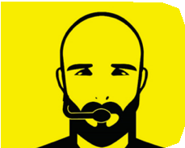Subscribe to Play by the Rules
Come and join the 130,000+ subscribers to Play by the Rules - it’s a great way to keep up-to-date with safe, fair and inclusive sport.

Back Issues
You can access each back issue for this magazine by visiting this page on the Play by the Rules website. All the feature articles and significant news items are listed here.

Share and spread the word
One easy way to keep up to date and support safe, fair and inclusive sport is to share Play by the Rules across social media. We post every day on Facebook and Twitter and have audio files on Soundcloud and an extensive collection of videos on YouTube and Vimeo.

http://facebook.com/playbytherules

http://twitter.com/playbytherules

@playbytherulessport

26 Play By The Rules | Magazine Issue 40
26

Play by the Rules and Sport Integrity Australia courses in one place

PBTR courses have now been integrated into the Sport Integrity Australia LMS (Learning Management System) which is co-branded with Play by the Rules. You can now find all of these
PBTR courses in one, easy to find place. Click here for the PBTR e-learning hub link and see below for a list of the courses you can access:

- Revised Child Protection Online Course
- Harassment and Discrimination Online Course
- Member Protection Information Office Course
- Complaint Handling Training
- Inclusive Coaching
- Creating an LGBTI+ Inclusive Club
- All mini-courses.

Hosting the Play by the Rules online training modules on the Sport Integrity Australia e-learning hub creates a single destination for all sporting codes and administration staff to access the
appropriate educational materials and training on sport integrity and will vastly improve the user experience in the process.

Bringing together the courses was a key recommendation from the Wood Review, which proposed a single identifiable education and outreach platform be established to develop and coordinate education, training and outreach courses.

The Play by the Rules online courses will be available on our website from
17 June 2021. The courses can be found at www. elearning.sportintegrity.gov.au

Play By The Rules | Magazine Issue 40 27

Our Partners

Click here for the new eLearning hub
– a collaboration between PBTR and Sport Integrity Australia – now hosting all integrity online courses in one single click destination
Did you know that Play by the Rules is one of the best examples of a Collective Impact approach to addressing sport issues in the country? Play by the Rules is a collaboration between multiple partners.

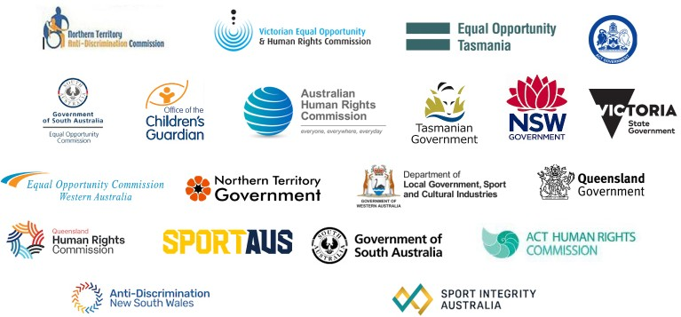

To make Play by the Rules possible, we also work with

