LGBTQIA+
Inclusion in sport
Why (and when) intention counts
Issue 41

PLUS
RelyOn podcast: Integrity in Sport with Elaine Heaney
Driving social change through sport
Diving into the conversation: Swimming NSW’s Youth Advisory Panel
Play By The Rules | Magazine Issue 42 1

Pride Celebration: The collaboration that’s making the pitch Proud
Bringing the dynamite. How can we truly shift the brick walls that stand in the way of equity?

SAFE FAIR INCLUSIVE SPORT

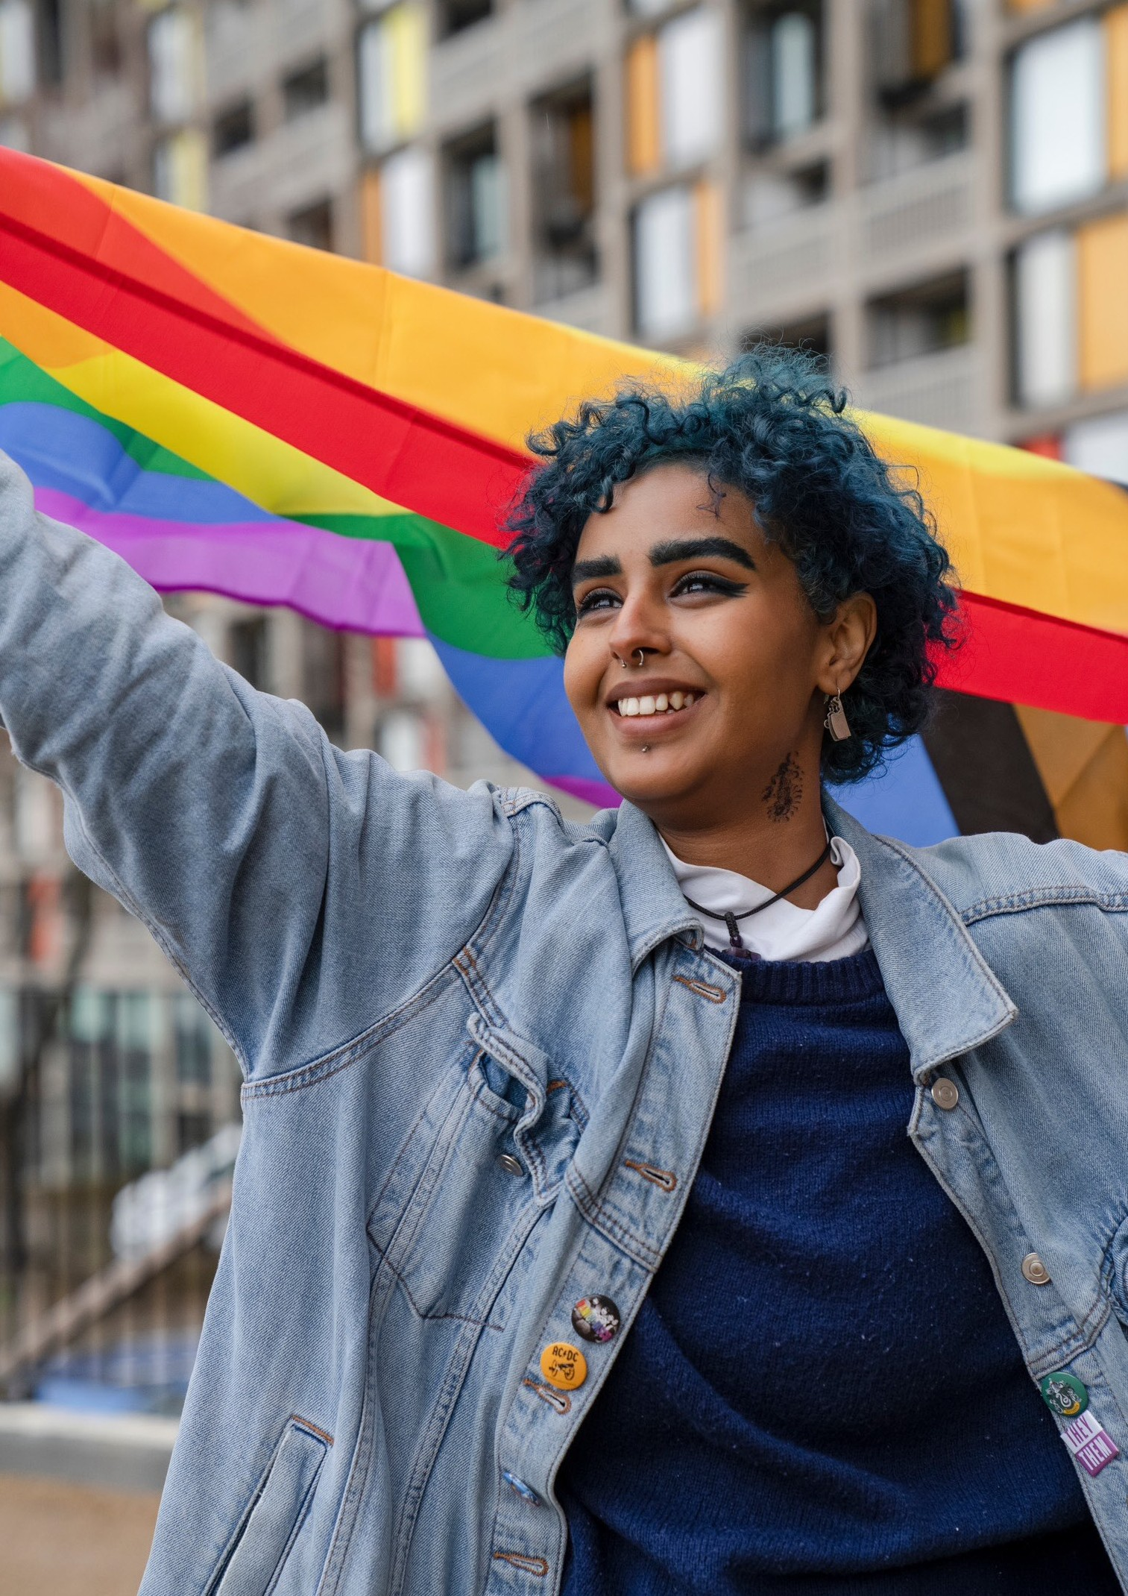

2 Play By The Rules | Magazine Issue 42

CONTENTS

State/territory
3
Play by the Rules contacts
4 The Editor
Driving social change through sport
6

Diving into the conversation: Swimming NSW’s Youth Advisory Panel
8

Bringing the dynamite. How can we truly shift the brick walls that stand in the way of equity?
10

LGBTQIA+ Inclusion in Sport: Why (and when) intention counts
12

RelyOn podcast: Integrity in Sport with Elaine Heaney
14

Pride Celebration:
22
The collaboration that’s making the pitch Proud

Subscribe to Play by the Rules Back issues
24
Share and spread the word

Play by the Rules and Sport Integrity Australia courses in one place
26

State/ Territory Contacts Calendar

Play By The Rules | Magazine Issue 41 3

EDITOR’S NOTE

Hello and welcome to the PBTR magazine! – a magazine which we hope will bring you inspiration, information and education about diversity and inclusion in community sport and showcase practical ways that you can create a safe, fair and inclusive space at your club.

Australia has had a busy start to the year with an amazing summer of sport. As well as becoming accustomed to hosting international sporting events which draw in the eyes of the world, Australia has been proud to host many other events which showcase just what a welcoming and inclusive nation we are. On top of the list - World Pride 2023 set the standard for an event that not only had the glamour and the glitz we all expect from our wonderful LGBTQIA+ community – but also hosted a World Pride Human Rights Conference which brought the ‘purpose’ of World Pride squarely into focus for all Australians. Having said that – there was also a fair amount of glitter and rainbows adorning the streets and our cities were all the more colourful and entertaining as a result!

As well as all the amazing street parties and parades, clear messaging from the World Pride Human Rights Conference was that taking time to meet, greet and understand the human next to you is the best way to learn more about that human’s world, what makes them who they are and what drives them. Being respectful, polite, welcoming and inclusive is the cornerstone
of every good sporting club’s code of conduct – and interactions with the LGBTQIA+ community should mirror that at all levels of society. Where someone is brave enough to speak about their journey in accepting who they are, transitioning into a space where they
can feel their true selves, or to speak of the challenges they have faced with being born with intersex or other diversities – the main thing we learnt was that our job is to listen with open hearts and minds.

Every human is diverse and unique – and we all need support, love and community to feel the sense of belonging that we know is so important. The more
we as a community can create those safe spaces for people to express themselves, live their best lives and make autonomous choices about their own bodies or identities – the more we as a nation are staying true to our human code of conduct – which is to be kind and welcoming to one another. Equally if anyone is struggling to find that sense of belonging, we really encourage you to speak up and talk to someone.
Our PBTR Mental Health pages have a range of resources and places to seek help and conversation but specifically – Q Life provides anonymous and free LGBTQ peer support and referrals - www.qlife.org.au/ get-help. Please don’t struggle alone – there is always someone there to listen.

At a club level for anyone who is interested in how they can help to create that safe and welcoming space please do check out the amazing resources and support of Pride in Sport, Proud 2 Play and Pride Cup. All of these wonderful organisations help LGBTQIA+ folks feel safe, welcome and accepted in sport and
showcase and guide sporting organisations along their journey towards being a welcoming and inclusive club. Play by the Rules also has a wonderful free e learning course ‘Creating an LGBTI+ Inclusive Club’ built in conjunction with Proud 2 Play that all of your players, officials, parents and community members can do to upskill themselves and work together to create the kind of culture that reflects the values of your club and its members. Finally we encourage you to check out the feature article of this issue by Ben Cork of Pride in Sport, who discusses why and when intention counts in taking forwards the ‘purpose’ of World Pride 2023.

Finally, a huge shoutout to the World Pride 2023 team who made such a wonderful event and incredibly moving conference a reality. Particular Kudos to Kate Wickett, CEO of Sydney World Pride and the World Pride 2023, Board, First Nations Advisory Committee, Pride Committee and all who were involved for putting Australia on the map and throwing such a legendary party with purpose! We see you, we appreciate you

4 Play By The Rules | Magazine Issue 41

and we acknowledge the extraordinary work it must have taken to put on such a whirlwind of stellar events. Gather, Dream, Amplify was the tagline to the event – and Australia certainly did that with style. We hope you all had a well earned rest and look forward to what else the future holds in the human rights space!

Happy Pride everybody – we hope you had a great one(!) – don’t forget to extend that welcome out to the whole community so everyone has the chance to move, be active and have fun in a safe space.

See you next edition! The PBTR Team
NB:

Further Resources

Pride in Sport’s Resources page

ACON’s Transgender and Gender Diverse Language Guide

Proud2Play’s Education page

Australian Sports Commission Trans and Gender Diverse Inclusion Guidelines

Head to Health Support for Intersex People ReachOut’s articles on Identity
IOC Framework on Fairness, Inclusion and Non-Discrimination on the Basis of Gender Identity and Sex Variations

Q-Life: Peer support and referral service

I acknowledge the Traditional Owners of country throughout Australia and other First Nations people from around the world and recognise their continuing connection to land, waters and culture. I pay my respects to their Elders past, present and emerging.
Play By The Rules | Magazine Issue 41 5

Driving social change

through sport

By Simon Rodder

CMSport is a new initiative from the Centre for Multicultural Youth that aims to support the sport, government, and community sectors to create more welcoming environments for multicultural Australians to be physically active. We are currently working with a range of state and national sporting bodies on projects that identify how policy and practice can be improved. Our direct connection to community can help sport address systemic barriers and create settings that foster a sense of belonging for culturally diverse communities, leading to improved mental and physical health outcomes.

As a country, we have always been proud that Australia is built on cultural diversity, and it’s now official… the majority of Australians come from a multicultural background. Data from the 2021 Census, released by the Australian Bureau of Statistics, shows that the proportion of Australian residents born overseas or who have a parent born overseas has increased to 51.5 per cent[1].

As our demographics change, so too should sport change, across all levels, to ensure everyone is inspired to engage in positive sporting environments.

Sport should reflect our community. When we look at athletes playing on sporting fields, decision makers in committee rooms, or people telling the stories through media, do we see our culturally diverse population reflected? Sadly not.
Sport is an industry and it has the power to shape us throughout our lives, and now is the time for the industry to lead the way by improving access to a sporting world that better reflects our community. From childhood we find our heroes on the sporting field and to quote US activist Marian Wright Edelman: “You can’t be what you can’t see”.

Whilst media attention has been squarely focused on issues of discrimination at the elite level, it is the systemic barriers that culturally diverse communities face when accessing grassroots sport that have the
greatest adverse effect. These barriers prevent young people from diverse backgrounds from being active, having fun, and improving their social connections.

At a local level, sports clubs can benefit from cultural diversity and inclusivity in many ways. For example,

through increased membership and volunteers, greater club capacity and sustainability, enhanced intercultural awareness, and a stronger connection with local communities.

The same applies for the administration levels of sport, where representation is a key step in improving inclusion. Diverse staff and leaders are essential for
creating more equitable opportunities in our community. Existing recruitment practices are limiting the opportunities available that lead to increased diversity.

Australia could look towards the USA in this regard, where proactive measures, such as the Rooney Rule in the National Football League (NFL)[2], have been put in place to ensure minority cultural groups have the opportunity to progress to the interview stage for
available jobs. Originating in the NFL, many other sports have adopted these or similar mandates, as well as non- sport leaders such as Facebook.

Some other key steps to improving cultural inclusion across all levels of sport include:

- Recognise that diverse communities aren’t all the same – understand the barriers communities are facing when trying to access sport and authentically work with them early in the process to develop programs and initiatives that suit their unique needs.

- Develop sustainable partnerships – create strategic collaborations between sport, recreation, government, and community organisations that will
help build engagement and support program design. Sharing resources and expertise can help to attract more Australians to be active and love sport.
- Commit to programs beyond ‘one-offs’ – establish sustainable and ongoing programs that demonstrate your commitment to working with diverse communities. This will result in improved trust and helps to avoid tokenism.

- Embed cultural inclusion – ensure the strategy, policy, and operation of sport is supported by standing agenda items and regular training opportunities that discuss diversity and inclusion. This will ensure the topic is always in conversations and continuous improvements are made and measured.

- Ensure a unified approach – bring your team along for the ride to help build respect for diversity across the organisation. The diversity and inclusion flag should be hoisted high by the organisation as whole, not waved by one individual

- Change the way you recruit – work with your partners to develop messaging that helps you speak to new and diverse audiences for your next
volunteer or paid position drive. This will ensure your organisation thinks differently and starts the process of change to better reflect the community.

The benefits of cultural diversity and inclusivity in sport are significant, the steps, tools and resources to get there exist, now is the time for the sport industry, at all levels, to be the leaders in driving social change and setting the benchmark for all industries.

Swimming NSW created a Youth Advisory Panel (YAP) consisting of approximately 15 teenage members in 2016 with the support of grant funding. We wanted to understand why kids drop out of sport, particularly in their mid-teens, and what could we do to keep them swimming. What better way to find the answers than to ask the kids themselves?

Diving into the conversation: Swimming NSW’s Youth Advisory Panel

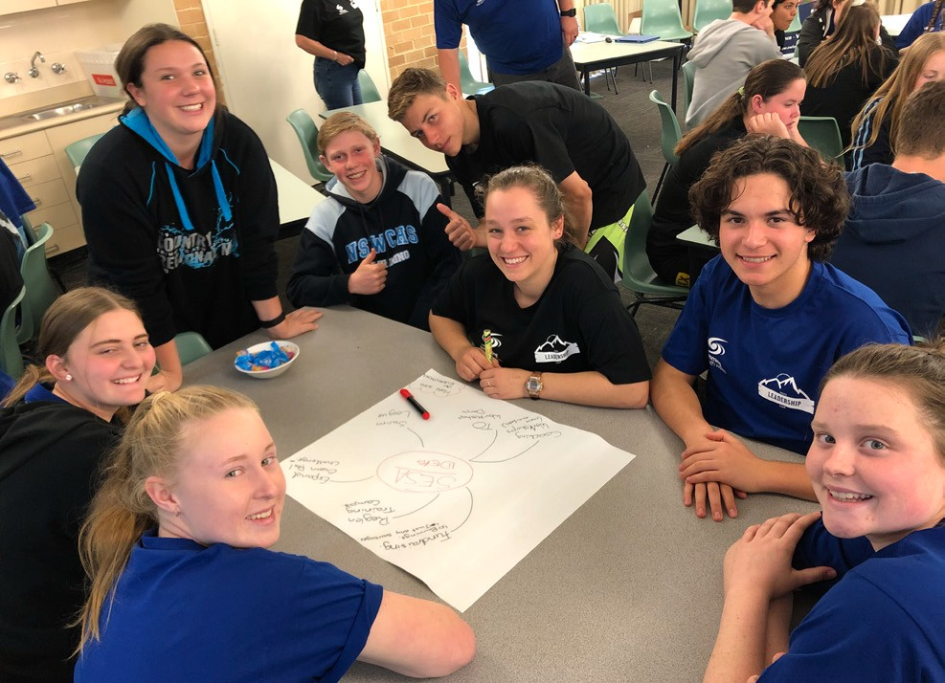
Each year we host a Youth Leadership Camp for 50 Swimming NSW members, with swimmers self-nominating before they’re selected to attend. Participants are given information and leadership skills that they can take back to their club to benefit the wider membership base, particularly their peers. There are multiple group bonding activities and education sessions held, including public speaking, time management, technical official and coaching information, and social event planning for their club. New members of the YAP are selected from the Camp graduates.

The YAP meets throughout the year via Zoom, working on various projects, and offering feedback and advice to Swimming NSW, Swimming Australia and other
organisations (e.g., Office of Sport) about their programs and policies. Swimming NSW also utilises the YAP members at events and functions which gives them valuable hands-on work experience.

From the outset the Board of Swimming NSW committed to implementing ideas generated by the Panel. This has developed a trusting working relationship where the young people feel valued and appreciated and the Board knows they have a reliable insight into their member base.

Standard 2 of the Child Safe Standards is “children participate in decisions affecting them and are taken seriously.” There are so many simple ways to meet this Standard in your organisation:

- Why not set up a youth group or junior committee and involve them in planning and decisions that affect them? They could send a report to the main committee meeting each month – e.g., their ideas are invaluable when it comes to designing ribbons, certificates, new logos, uniforms, or how to make training more fun (hint: they love music!)

- Ensure you have nominated Club Captains (elected by the kids as well as the parents!)

- Ask the young members (and in fact all members) what they like or don’t like via surveys, focus groups, or anonymous suggestion boxes

- Older teenagers or young adults are highly capable with social media and if given the responsibility can really lift your club’s social media presence and make it appropriate to the right audience

- Having teenagers support and assist with younger members is another great way to encourage leadership and responsibility and give those older teen members a real sense of purpose.

The most important thing to remember when involving young people in decision making is that you must
be prepared to act on their ideas. Maybe not all their suggestions, but at least some of the achievable ones. By doing this, you will build up trust and they will realise they are important to your club and can make a positive difference.

Young people are the future of sport. Just ask them and listen to them! You will not regret it.

Written by Sarah Koen, Sport Development and Participation Manager, Swimming NSW

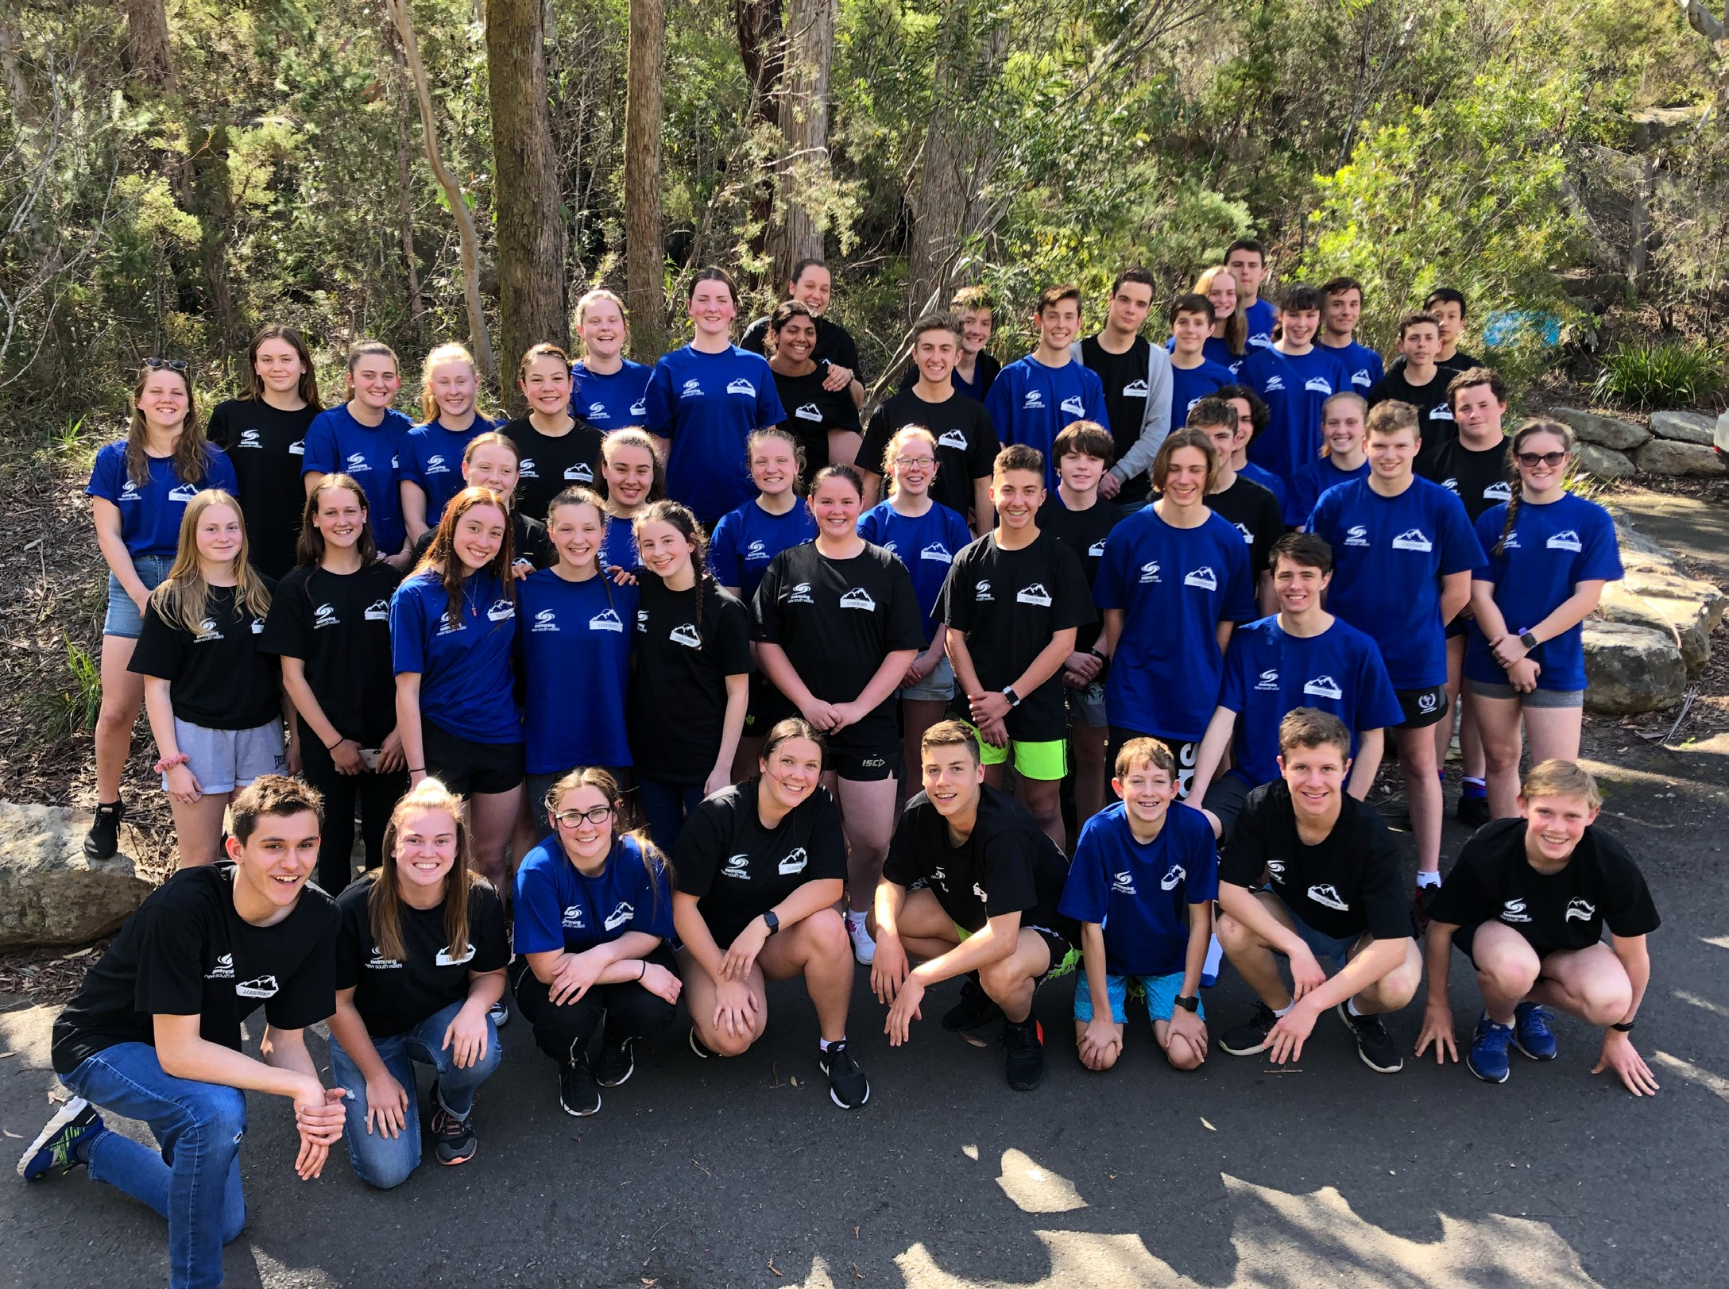

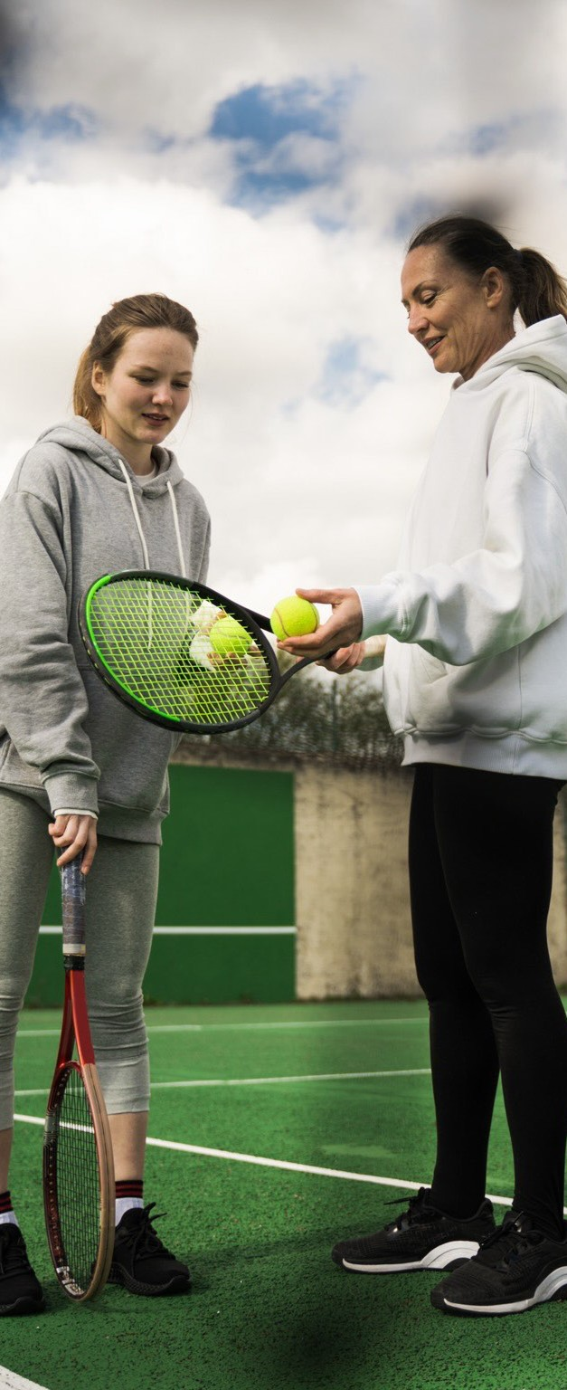

Bringing the
dynamite
How can we truly shift the brick walls that stand in the way of equity?

Play By The Rules | Magazine Issue 41
1010

At the Women in Sport breakfast, hosted by Women Sport Australia, at Marvel Stadium, I listened to Dr. Fiona McLachlan who outlined the fact that despite our efforts we really haven’t come that far when it comes to equity in sport. And it made me think, what are the brick walls that sport needs to shift and where can I find the dynamite?

What is certain, is that the current programmatic approach to fixing the issues cannot solve the challenge alone. Putting women through leadership courses, creating Champions of Change and ‘come and try’ programs for underrepresented groups at sporting clubs, are a good start and provide sport with easy-to- report numbers, however, what they don’t tell us is what happens after the course is complete, the day is run, and the cameras are no longer rolling?

Sport does need education, and ways to connect with new and emerging communities and for leaders to use their privilege to give others a seat at the table, but we tend to stop there. What I believe we need is for the industry to take the next step and ensure that the culture of our sports is one of inclusion and that
everyone can feel like they belong. Until sports do that, we will always be scratching the surface, as a sense of belonging is where true inclusion lies.

Sports need to review their existing systems and structures that underpin the delivery of sport. We need to understand what it feels like to be part (or not part) of a sport and how to address the barriers to
change the culture of what people walk into so we are truly representative of society. This can only happen
if representatives from all walks of life are engaged in the process of change and are empowered to make decisions. Sport needs to co-design its responses and
adopt the guiding principle of ‘not about me, without me’ to involve those that we are trying to engage.

The balance of power is starting to shift through the development of policies such as Change Our Game’s “Fair Access Policy Roadmap”[1], which addresses the issue of equitable access to sporting amenities for all. However, policies alone are not enough. The industry needs to have a no tolerance approach, like we do with child safeguarding, and give the sports and the people that run them the support, resources and education
to change the systems, frameworks, structures and
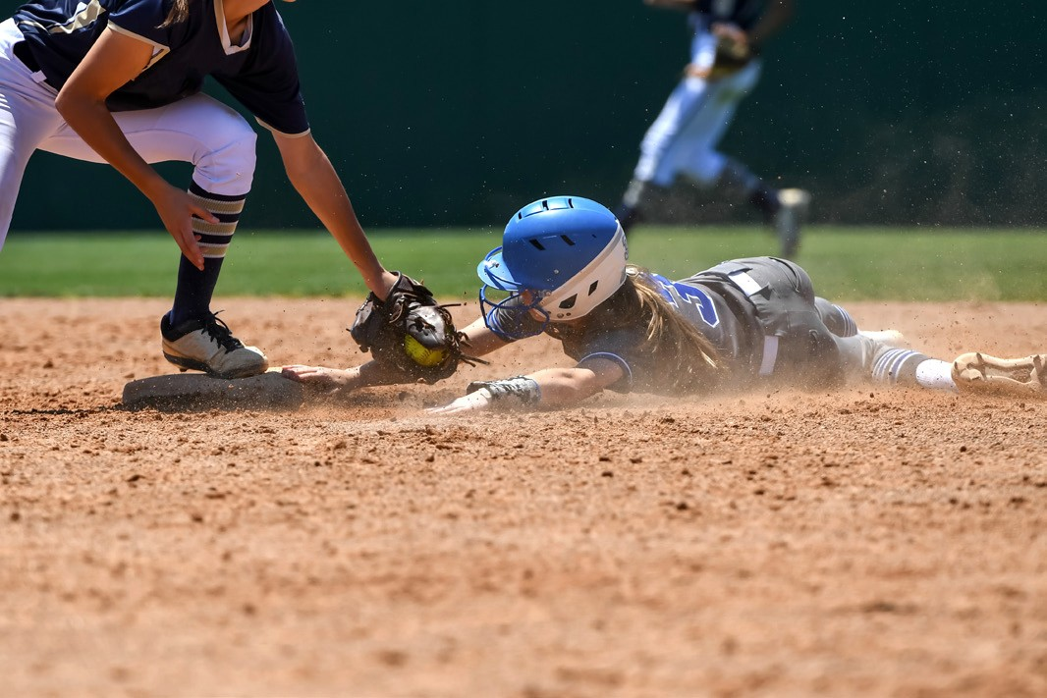

ultimately culture to support inclusion and make no excuses for those that don’t - accountability is key.

The personal challenge for each of us involved in sport is to look at ourselves in the mirror and ask: ‘Are we truly inclusive in all aspects of what we do, both on and off the field, and at all levels?’ If the answer is ‘I don’t know, no or maybe not always’, we need to determine how important it is to us and what are we willing to do to make this happen. Realistically, true change may mean that for some of us, our time is up and it’s time to pass the baton so sport doesn’t look like it does now in 10 years’ time.

With policies that foster a culture of true inclusion, and a personal commitment from every person involved in
sports to wholeheartedly get on board, we might just find the dynamite we need to shift the brick walls currently blocking our way.

About the author:
Tamatha Harding is Head of Tennis Delivery at Tennis Victoria and is on the board of Women Sport Australia. She is also a Consultant in Strategy and Project Planning, with more than 25 years of experience in the sport industry to inform programming, development and strategic projects for sporting and non-sporting organisations.
In her time with Tennis Victoria, Tamatha has worked in a variety of roles, including Inclusion Lead, Project Leader of Female Participation, Special Projects Lead, Executive Manager of Community Tennis, and interim CEO.
From 2017-21, Tamatha sat on the Darebin Women’s Advisory Committee, helping to advise Council on gendered issues and barriers to equality for women of diverse backgrounds. From 2008-12 Tamatha was a member of the Women’s Sport Advisory Group, which was set up by VicSport and Sport Recreation Victoria to represent women in sport and increase female participation.

Significant strides have been made over the last decade to develop more inclusive policies and practices in sport, and as a result, sporting cultures continue to evolve towards more sophisticated acceptance and inclusion. Pride in Sport works with sporting organisations and communities to encourage a welcoming and inclusive environment at all levels of sport in Australia.

LGBTQIA+
Inclusion in Sport:
Why (and when) intention counts

The resources funding those improvements have often been allocated and justified using an argument focused on the business case for inclusion[1]. And it is a strong argument. Because it works.

Dr Ryan Storr, Proud 2 Play Co-Founder, commented in 2021 that often Australian Sporting Organisations (ASOs) approach inclusion of people with diverse sexualities and/or genders with a focus on “brand, bottom line, and goal to increase participation, rather than the desire to enrich the lives of LGBTQI+ people or ultimately achieve the elusive goal of creating social awareness, widespread change, and positive community impact.”[2]

As National Sporting Organisations (NSOs) continue in their trend towards corporatisation, good governance, and growth, ‘brand and bottom line’ can be considered key reasons for increasing participation and inclusion. It’s an agreement of sorts; sport invests in LGBTQ inclusion, to produce a tangible, financial measurable benefit. But does this take into account the humans at the core of your organisation?

It can be a big ask for the LGBTQ community to expect major sporting codes to support inclusion and use their (significant) social reach to enact progressive social
change, particularly when ‘increasing participation’ might not seem vastly different to ‘enriching lives’. When in
fact weaving recognition, inclusion, and acceptance of the LGBTQ community into the values of a club is about much more than simply bringing more bodies on board in order to increase participation targets.

There have been clear wins in the last decade. LGBTQ visibility has improved for marginalised communities. Policies and procedures have been updated to reflect evolving societal attitudes and changes to legislation. An ever-increasing number of out and open LGBTQ people are role models for the next generation of emerging athletes and are celebrated by their communities. The last decade has been inspiring and it has seen change beginning to emerge in the sporting arena. But there is still much to be done.

Even with the best of intentions, as within society, communication and advocacy, homophobic, biphobic and transphobic attacks will continue to occur in sport. The translation of policy to culture, from the boardroom to the field of play (or pool, course or court), takes time – and even then, it is never perfect. Sport is a microcosm of our society, and it is unrealistic to think that all such unwanted behaviours can ever be completely eradicated.

At Pride in Sport, we believe it is an organisation’s response to discrimination, bullying, harassment, and vilification that establishes their credibility as an inclusive sport. This is where the why is vital.

When sports are faced with high-profile incidents of homophobia, biphobia or transphobia, the lens

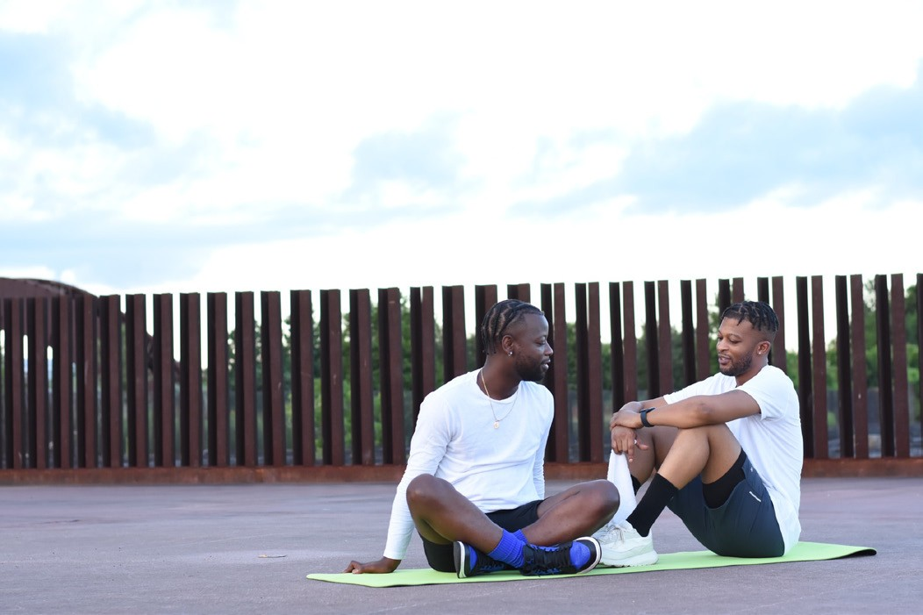

through which these situations are viewed drives the conversation, the process, and the response. That lens, and the response of the sport or club at that time, says a lot about the sport’s values system.

Homophobic conduct should not be weighed against business outcomes. But often it is. Transphobic statements should not be considered in the context of brand and budget. But often they are. Zero tolerance should mean zero tolerance, even when it affects the bottom line.

Inclusion for the purpose of enriching the lives of LGBTQ people in Australia is a very different goal – and one which ultimately puts the humans first. This should
be the goal of every sporting organisation in Australia – above and beyond the bottom line or reputational considerations.

The LGBTQ community has been actively targeted in campaigns to reconnect with organised sport using a promise of inclusion and respect. When sports do not live up to this promise[3], they risk being called out for tokenism and ‘non-performative institutional speech acts’[4] and this is why putting the values of the sport or club first is so important. It is in these moments of conflict and crisis when it’s important to understand what drives inclusion in your sport – and making sure those drivers are values based and clearly defined, for everyone.

The development of professional, well governed sports has benefited millions of Australians, and created opportunities for participation we should all be proud of. However, there is a limit to what cost can be measured, and what benefits can be captured within a KPI.
Truly visionary sports recognise the broader role NSOs play in our communities. Truly inclusive sports
understand the limits of, and move beyond, the business case for LGBTQ inclusion.

Business case-based motivation is not always a bad thing and has brought us Pride Rounds, Mardi Gras floats, jerseys, and merchandise, amongst many other good things. However, arguably, any time profit takes precedence over progress, it is visibility at the expense of real change. So, the question we need to keep asking is: are you putting the humans first? How, and more importantly why, can your organisation effect change in this area, and why is it important to you and participants in your sport?

Once you know the why, the rest becomes much clearer, and real change can begin.

Please visit prideinsport.com.au for more information, resources, initiatives and news.

For further support and advice, please contact the Pride in Sport team via info@prideinsport.com.au

About the author:
Ben Cork is a Project Officer at Pride in Sport. Pride in Sport is a national not-for-profit sporting inclusion program specifically designed to
assist sporting organisations of all levels with the inclusion of employees, athletes, coaches,
volunteers and spectators with diverse sexualities and genders. For more information and support please visit our website or contact us directly at info@prideinsport.com.au.

- Cunningham, George & Hussain, Umer. (2020). The case for LGBT diversity and inclusion in sport business.
- R. Storr, “The poor cousin of inclusion”: Australian Sporting Organisations and LGBT+ diversity and inclusion, Sport Management Review (2020), https://doi.org/10.1016/j.smr.2020.05.001
- Storr, R., Parry, K. D., & Kavanagh, E. (2018). “We are a sport for all Australian’s” : exploring the non-performativity of institutional speech acts around LGBTI+ diversity in Australian sporting organisations.
- Ahmed, S. (2007) ‘“You End Up Doing the Document Rather Than Doing the Doing”: Diversity, Race Equality and the Politics of Documentation’, Ethnic and Racial Studies 30(4): 590–609.

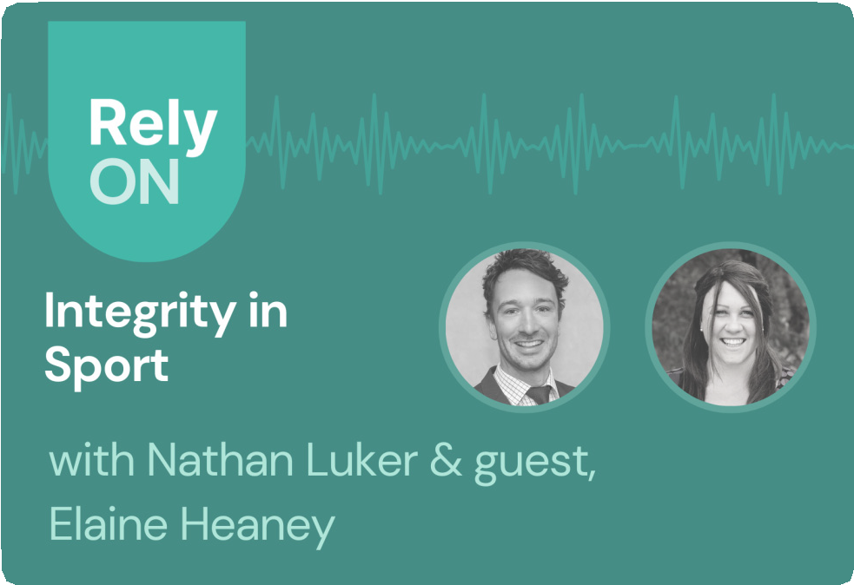

RelyOn podcast

Host, Nathan Luker, talks to National Manager of Play by the Rules, Elaine Heaney, about integrity in sport. In Australia, 80% of adults and
40% of kids play sport (outside of school), and that doesn’t include spectators!

In this podcast (30 mins), Nathan and Elaine discuss:

  - How to influence a large population of players and spectators to be ‘good sports’
  - The role of technology in helping players and spectators speak up when they experience or see poor behaviour in sport
  - Elaine’s key learnings from the Know It. Live It. Log It program she ran at Scouts NSW, including why minor issues can signal something bigger at play
  - The importance of strong leadership to build an integrity-led culture

Originally published on the Rely website.

Nathan Luker [00:00:01]
Welcome to the RelyOn Podcast. A show that delivers practical insights for leaders to build better
organisations where people can live, work and study. I’m Nathan Luker, co-founder at Rely, where we help some of the best known brands prevent, detect and respond to culture and conduct issues via our intelligent platform. Welcome back to the show. Today, I’m joined by Elaine Heaney, national manager of Play by the Rules. And we’re exploring integrity in sport. Welcome, Elaine.
Elaine Heaney [00:00:32]
Lovely to be here. Thanks for having me.
Nathan Luker [00:00:34]
Okay. To start at the beginning, you were born in the
U.K. You started your career in criminal and regulatory law. You then moved to Australia in 2013, where you joined KPMG. Then you move to the Law Society of New South Wales in a policy role, and then you moved to child protection with the Scout Movement just after the Royal Commission. And then you’ve joined Play by the Rules
in 2021. That’s a lot on the scoreboard. You’ve made an impact all around the world. Can you tell us a little bit about where your passion for promoting ethical conduct has come from?
Elaine Heaney [00:01:06]
I think that’s a really good question. I think you learn along the way the things that drive you. And I think justice has always been a big part of my life since I was 18 and decided I wanted to become a lawyer. I always feel like what’s right and understanding what society perceives as being right is a really interesting sphere and then accountability attached to that. So obviously within criminal law, you learn what the government and
legislation feels is correct conduct. And when someone falls short of that, how they get held to account by our laws and criminal justice system. And similarly, when you go into any sporting environment, you have to look at the environment people are operating in and what standard we want to hold them to account to. So it’s all that similar level of how do we want humans to act or behave.
Nathan Luker [00:01:54]
Interesting. And when you were the child protection officer at Scouts New South Wales, I think from what you’re saying that really came through because when we do a lot of our work, we try and promote leaders to make an impact. Builds, creates a legacy and you pioneered know it, live it, log it for youth safety. It just came through. Where did you start? How did you do that? How did that start?
Elaine Heaney [00:02:18]
It’s such a great campaign and we were so proud of it. It’s about trying to inspire people to understand sometimes quite complex matters and then break them down into something that’s more easy and tangible to understand. So we, you know, probably timing wise, I arrived at Scouts just post Royal Commission. Obviously, they were looking to look into their safeguarding measures, enhance their safeguarding measures, and make sure that they were putting forward policy and practice that was accessible to the wider audience. And so I worked with everybody there to make sure that we understood what risk was, what risk mitigation measures were, and then how could we get people who were out at events
to make sure that they understood what was expected of them and to deal with anything that might come up where conduct fell short of that and so know it, live it,

log it, was about knowing the code of conduct, living and breathing it in everything that you’re doing and then logging if you had an issue. And I think once we got that messaging out to the adults and the young people, they really took that on board.
Nathan Luker [00:03:25]
We talk a lot about programs that are for show or for real. And a lot of these, unfortunately, are for show and from all the research we’ve done. This was very much
a for real program that really cut a cord and got cut through into the DNA of the organisation. What was the moment where you knew it was working? Because that would have taken some time. As you said, you went through a pretty tough time as an organisation. Can you talk us through the evolution of the strategy and how did you know? Hey, hang on. There’s some pattern recognition here. People are trusting the program.
They’re living it.
Elaine Heaney [00:03:59]
Yeah, I think I think once people start saying the words back to you, I think when there’s a concept that you’ve created, you know, and we had a really great team
that kind of put it all together and worked through the different age groups and scouts and how we were
going to try and attack that to make sure it was simple and clear enough for everyone. But when you’re out
at an event and you’ve got kids coming up to you and saying, know it, live it, log it, or you’ve got adults who understand the concept and the risk and how to say that back to you and understand the why. As much as anything, I think that’s the most important thing of all, because then you’re not just educating with the
policy, you’re educating as the reason for the policy and
allowing people to start making those risk decisions themselves. And that’s really what we want to do, is empower people in those situations to understand what’s expected of them and others, and to be able to take action where necessary. And if they can make that judgment in a more informed way, then that’s where we’ve done our job.
Nathan Luker [00:04:55]
Yeah, exactly right. And I think the ripple effect from that with young persons infiltrating, I guess the way that they perceive situations, and it was wonderful to see that when in doubt, log it and it says the threshold for success here is pretty low. If something doesn’t seem right, just let us know about it. You know, you don’t
need to be an expert to try and diagnose problems or anything, which is brilliant. And having it out at a student level, you know, that’s building the leaders of tomorrow, particularly in the scout framework.
Elaine Heaney [00:05:24]
Yeah, I hope so. Thank you. It’s for me, it’s all about a safe space as well. So it’s a safe space, obviously, physically, but it’s a safe space psychologically to be able to raise things, to be able to talk freely and to be able to work through things with people. Obviously, you know, fear
of reprisal is very real. And we understand that people are worried and concerned when they have to bring something to the table. But what we want to say is that there’s experts here for a reason who are here to help you with this stuff. Come forward, speak to us, put in a report, and then we’ll help you work through that. And I think if people can see that you’re a genuine person who really wants to help them and enter into a conversation with them, then it’s not just sending a report off into the

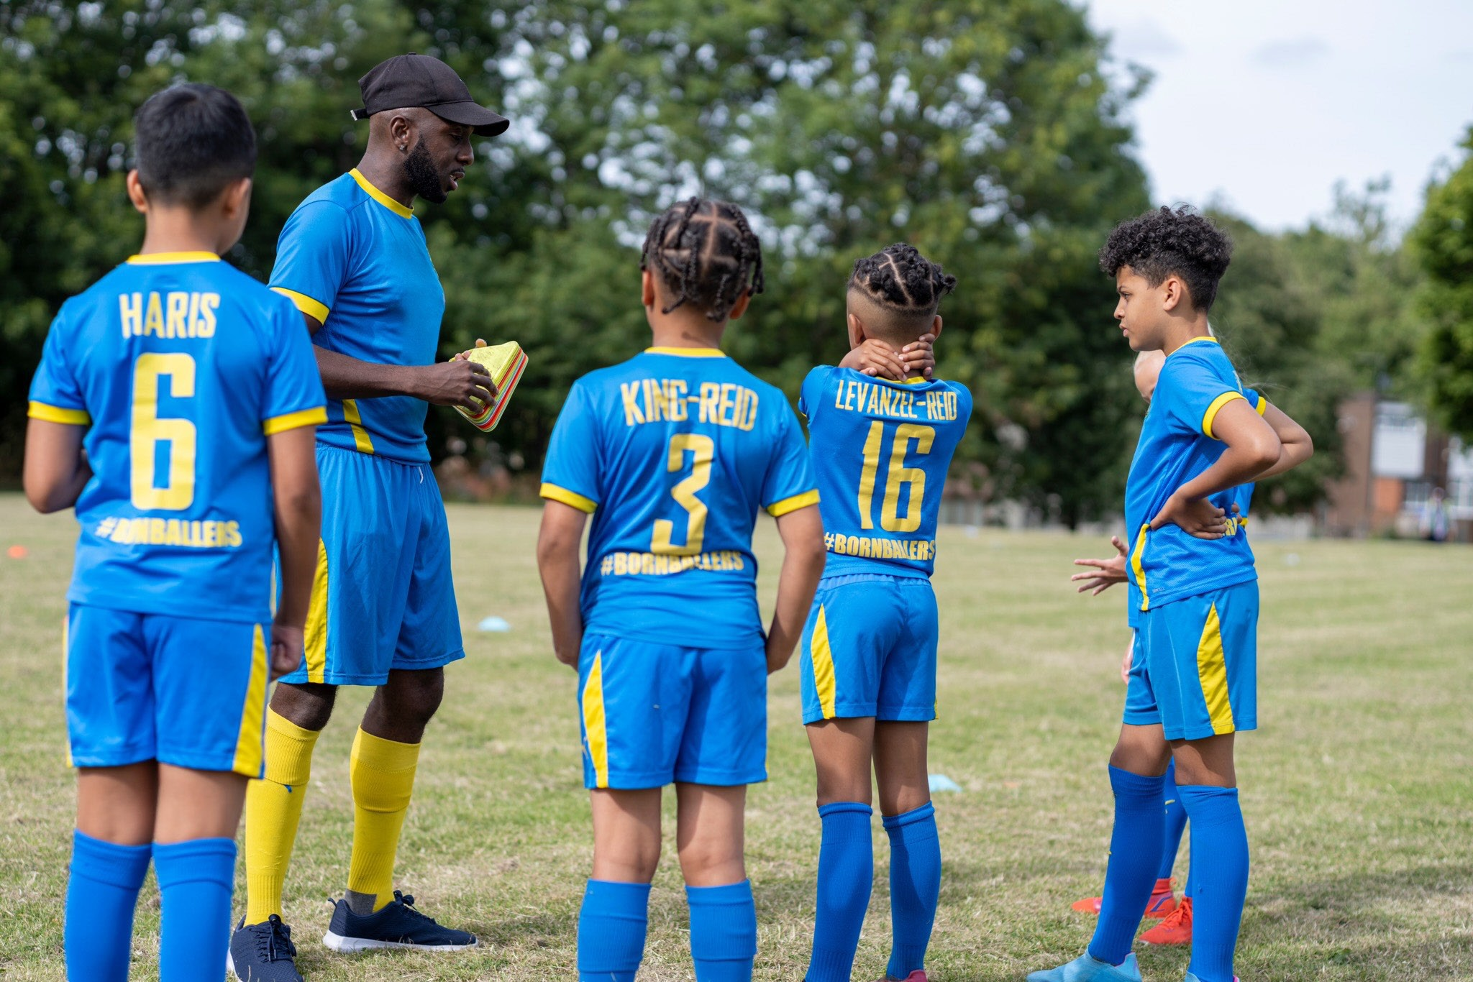

ether and the unknown. They know it’s going to a real person. They understand the process that’s attached to that, and then they know that we’ll help them.
Nathan Luker [00:06:13]
One thing. We work with hundreds of schools, young persons and in sport as well. A common question is if we take that approach, if we lower that threshold and have when in doubt, log it type mentality, we’re going to be inundated with vexatious reports. You know, kids being kids know you don’t know where it’s going to go. Was that your experience talking in general terms, and what guidance would you give our listeners who are in that position of how to approach that?
Elaine Heaney [00:06:42]
Yeah, it’s a really good point, and I think it’s understandable that there’s many reasons why people might put in a report. You know, humanity is complex, situations are complex and people are complex. But what I would probably say is that would an organisation, rather than know what’s going on, whatever the reason driving that might be, so that they can spot risks and patterns and behaviours and understand, you know, information is power. At the end of the day, if you don’t know about a risk, you can’t act on it. So number one,
I would rather always just have all of the information and 1000 reports rather than one, no matter what the situation. And then number two is, I think you have to start from a point of belief. If someone has gone to the
effort of putting in a report to say that there’s a behaviour that they’re not happy with. Start with the belief that
that is true and that there’s something there that needs to be addressed and then you can work through when you’re listening to person A and listening to Person B and weighing up the evidence and thinking about where that sits and against your code of conduct as to a judgment as to the situation. And you can’t make that judgment based on one report. You can make that judgment based off speaking to different people and working through what the situation is.
Elaine Heaney [00:07:56]
And it’s not always, you know, black and white, sometimes the shades of grey, Sometimes there’s many different things that people don’t realise are going on. And you as a person in that situation with responsibility and accountability, want to make sure that the people in your organisation, if there’s an issue, you can help
to resolve that and a low level that might just be that. There’s been a disagreement somewhere along the line, probably because of a lack of communication in my experience, and you can sit people down and work through what the issue is. You might end up with a happier, you know, volunteer workforce than you had previously, because people have been listened to and
have had that time taken to work it through. Now the flip side of that is the amount of work involved is obviously you have 1000 reports. It can be tricky, but I think if you start from that place of being welcoming and open and then you learn to triage effectively as you go after four years there, I certainly learned to kind of work my way through all of the different reports and triage them in a way that we felt was appropriate. So that’s the job.
Nathan Luker [00:08:59]
Yeah, well said. Strong leadership is a regular part of the process that gets missed and overlooked. So you’ve just talked about a really strong personnel
response, yet a strong team, yourself included. We were looking at everything equally, had a process in place, had a continuous improvement plan and essentially understood. Yep. Okay, we’re going to kick off. It’s going to be large and a little bit messy, but we’re going to take everything seriously and get better over time. A really important point I think gets missed regularly. There has to be a bit of pain before you can get the momentum going in the program where it’s self sufficient in a way, especially working with young people, though it’s nearly mandatory, it’s a mandatory requirement. The system then takes care of itself. If you adopt that over time,
the participants in that system know that there’s a low threshold of reporting and that each report is going to be taken seriously and it self corrects itself. You know, our experience that leads to as a prevention mechanism to bad behaviour in itself, the very nature of a program.
Elaine Heaney [00:09:59]
If you go back to that criminal law concept of if you have 1000 reports, are you still able amongst those thousand to spot any indicators of a level of criminal conduct or abuse that might be present? And if so, triage them to the right place, to the police, to the criminal protection agencies to make sure that the right other people are dealing with them, then that’s the point of the system.
You know, the lower level bullying type, especially adult to adult matters, is a whole sort of another facet. But that’s not the really important stuff that we’re looking for. What we’re looking for is those flags, those indicators, creating that space so that people can come forward and tell us about the really serious issues, because those are the ones that you want to make sure that you’re triaging off to the right place.
Nathan Luker [00:10:41]
I want to jump back to a point you made earlier about repercussions and reporting and reprisals. In our experience in sport in general terms, we track a lapse time. So when the incidents happened so victim survivors of violence, abuse or sexual harassment, when the actual incident or incidents occurred and when they told us and generally that elapsed time is quite long, it takes a long time for someone to choose to speak up for good reason. In your experiences then moving from scouts into sport, what do you believe creates the right
environment where people feel they’ll be seen, heard and believed without that fear of repercussions?
Elaine Heaney [00:11:18]
Yeah, I think it’s really important to think about proactive versus reactive and Play by the Rules sits is very much
in the proactive space. So the reactive space, just to kind of start there is where in incidents happen, there’s been some conduct that’s an issue that gets reported to the right place and triage through the process and you can end up with enforcement and sanction at the end of it depending on what the system or process is that you’re going through. Where Play by the Rules sits is we don’t sit in that reactive space. We don’t deal with

the reports that come in to any sports. But what we do do is proactively try and educate the community
particularly, but all levels of sport as to what appropriate behaviours are, what a code of conduct is. Upskilling yourself in human rights principles such as harassment and discrimination to make sure that you’re not allowing anti-racist behaviour, any discriminatory behaviours, LGBTQ plus victimisation, for example. All of those ways in which you can upskill yourself allow you again to spot those behaviours, understand that they’re unacceptable, and then triage them to the right place. And if we can even just set the tone in the first place to say that where you should start is a safe, fair and inclusive environment, which is the tagline for Play by the Rules and everything that it encompasses you as a community club need to think about who you are and who you want to be and what your values are. And I would hope and think that with most clubs that’s about creating that safe and welcoming space for everybody to come into.
Elaine Heaney [00:12:50]
And what we want to do is we know that volunteers are time poor. We know that there’s a lot of admin involved in running community sports clubs. We want to try and make that process easier. So we want to try and create campaigns and create resources and create online free e-learning so that people at that community club level can upskill themselves to be able to proactively educate their community as to the type of behaviours they expect and want, and then make sure that people are abiding to those standards. So a good practical example of everything that I’ve just described is the Let Kids
Be Kids campaign. So that’s about sideline behaviour. When a sporting event is taking place, instead of having parents screaming at the kids or screaming at young referees, we can have 15 year old referees. For example, if you have a 40 year old on the sideline screaming obscenities at a young person who’s refereeing, that’s unacceptable on every level. It’s unacceptable. And that should be called out and people should understand that that behaviour is unacceptable and then something should be done about it. But unless people are aware that they have the right to call people out in that situation, then people don’t understand what that expected behaviour is. So that’s where we sit is in that proactive space to try and get people to understand those kind of issues.
Nathan Luker [00:14:09]
You talked about sideline behaviour, and it seems to have never been more difficult at time to be managing this type of conduct or sector. 80% of Australians play sport. 40% of children. There’s mobile phones, there’s connectivity. There is. We were speaking to one school recently, referring to children. There’s no children here. They’re mini adults. You know, the speed of maturity, it’s just is on hyperdrive. Do you think it’s working? Because we say this regularly where at a club level there’s bad behaviour, with sideline behaviour seems to be getting worse. It’s also more complicated, more connected.
Bullying is happening in the shadows. What data or information do you have to share with the campaign? I love Let Kids Be Kids, is a wonderful campaign.
Elaine Heaney [00:15:00]
Yeah, absolutely. So I mean, I think if I start with the sort of concepts first and I’ll come back to the, I would say data being from the UK afterwards. Yeah, I think that one thing we need to make sure we don’t do is, is take sport and the sporting community and sporting environments and take them outside of normal community and normal humanity. You know, everything that happens on the sporting field should be is subject to the same expected behaviours of everybody in society, in the supermarket, at the park, walking down the road outside of school.
All of those situations are no different to sporting situations. And I think the problem that we have is when some people walk into that environment thinking that they have an entitlement to do what they want because they’ve paid fees, because their kids go there, because they’re passionate about sport and that’s not correct.
We need to make sure that people understand that sporting environments sit in that same sphere of having expectations attached to it. If you sign up your child or you buy a ticket to a match, you know you are entering into an environment that has expected behaviours and you’re agreeing to abide by that club’s code of conduct, their policy and processes in relation to behaviour. And so I think just making sure that people understand that criminal conduct applies just the same, child protection matters apply just the same as they would in any other aspect of community, and that you don’t get to get away with things more just because it’s related to sport and you might be passionate about your sport. And then the second point onto that is I don’t have data in relation to incidents, but what I can tell you is that Play by the Rules has grown. So back in, I think it’s 2014 we had about 15,000 people doing e-learning and in 2020 we had about 60,000.
Nathan Luker [00:16:50]
Wow.
Elaine Heaney [00:16:50]
For me, that shows the appetite growth for the program and for helping people. Now, the problem with stats is you can go one way or the other. You could say on the plus side and the positive side, that’s an incredible swell of people who want to help deal with this, work through these issues and upskill themselves. On the other side, you could say there’s a growing problem enough for people to need to deal with it. I think both are true. I think nothing is ever straightforward. Nothing is black and white. So it’s not just it’s got worse or it’s got better. For me, having worked in criminal law and in child abuse matters and in lots of other spheres of work, humanity exists. There will always be people who test boundaries and there will always be people who do things wrong.
We can’t eliminate that. But what we can do is create environments where those kind of behaviours are less acceptable, less likely to occur, and that they’re called out and dealt with as and when they do so.
Nathan Luker [00:17:48]
It’s great to hear about the growth and the e-learning adoption. So hopefully there’s a broader level of preparedness at a club level and there’s obviously a lot happening with the national integrity framework, etc.

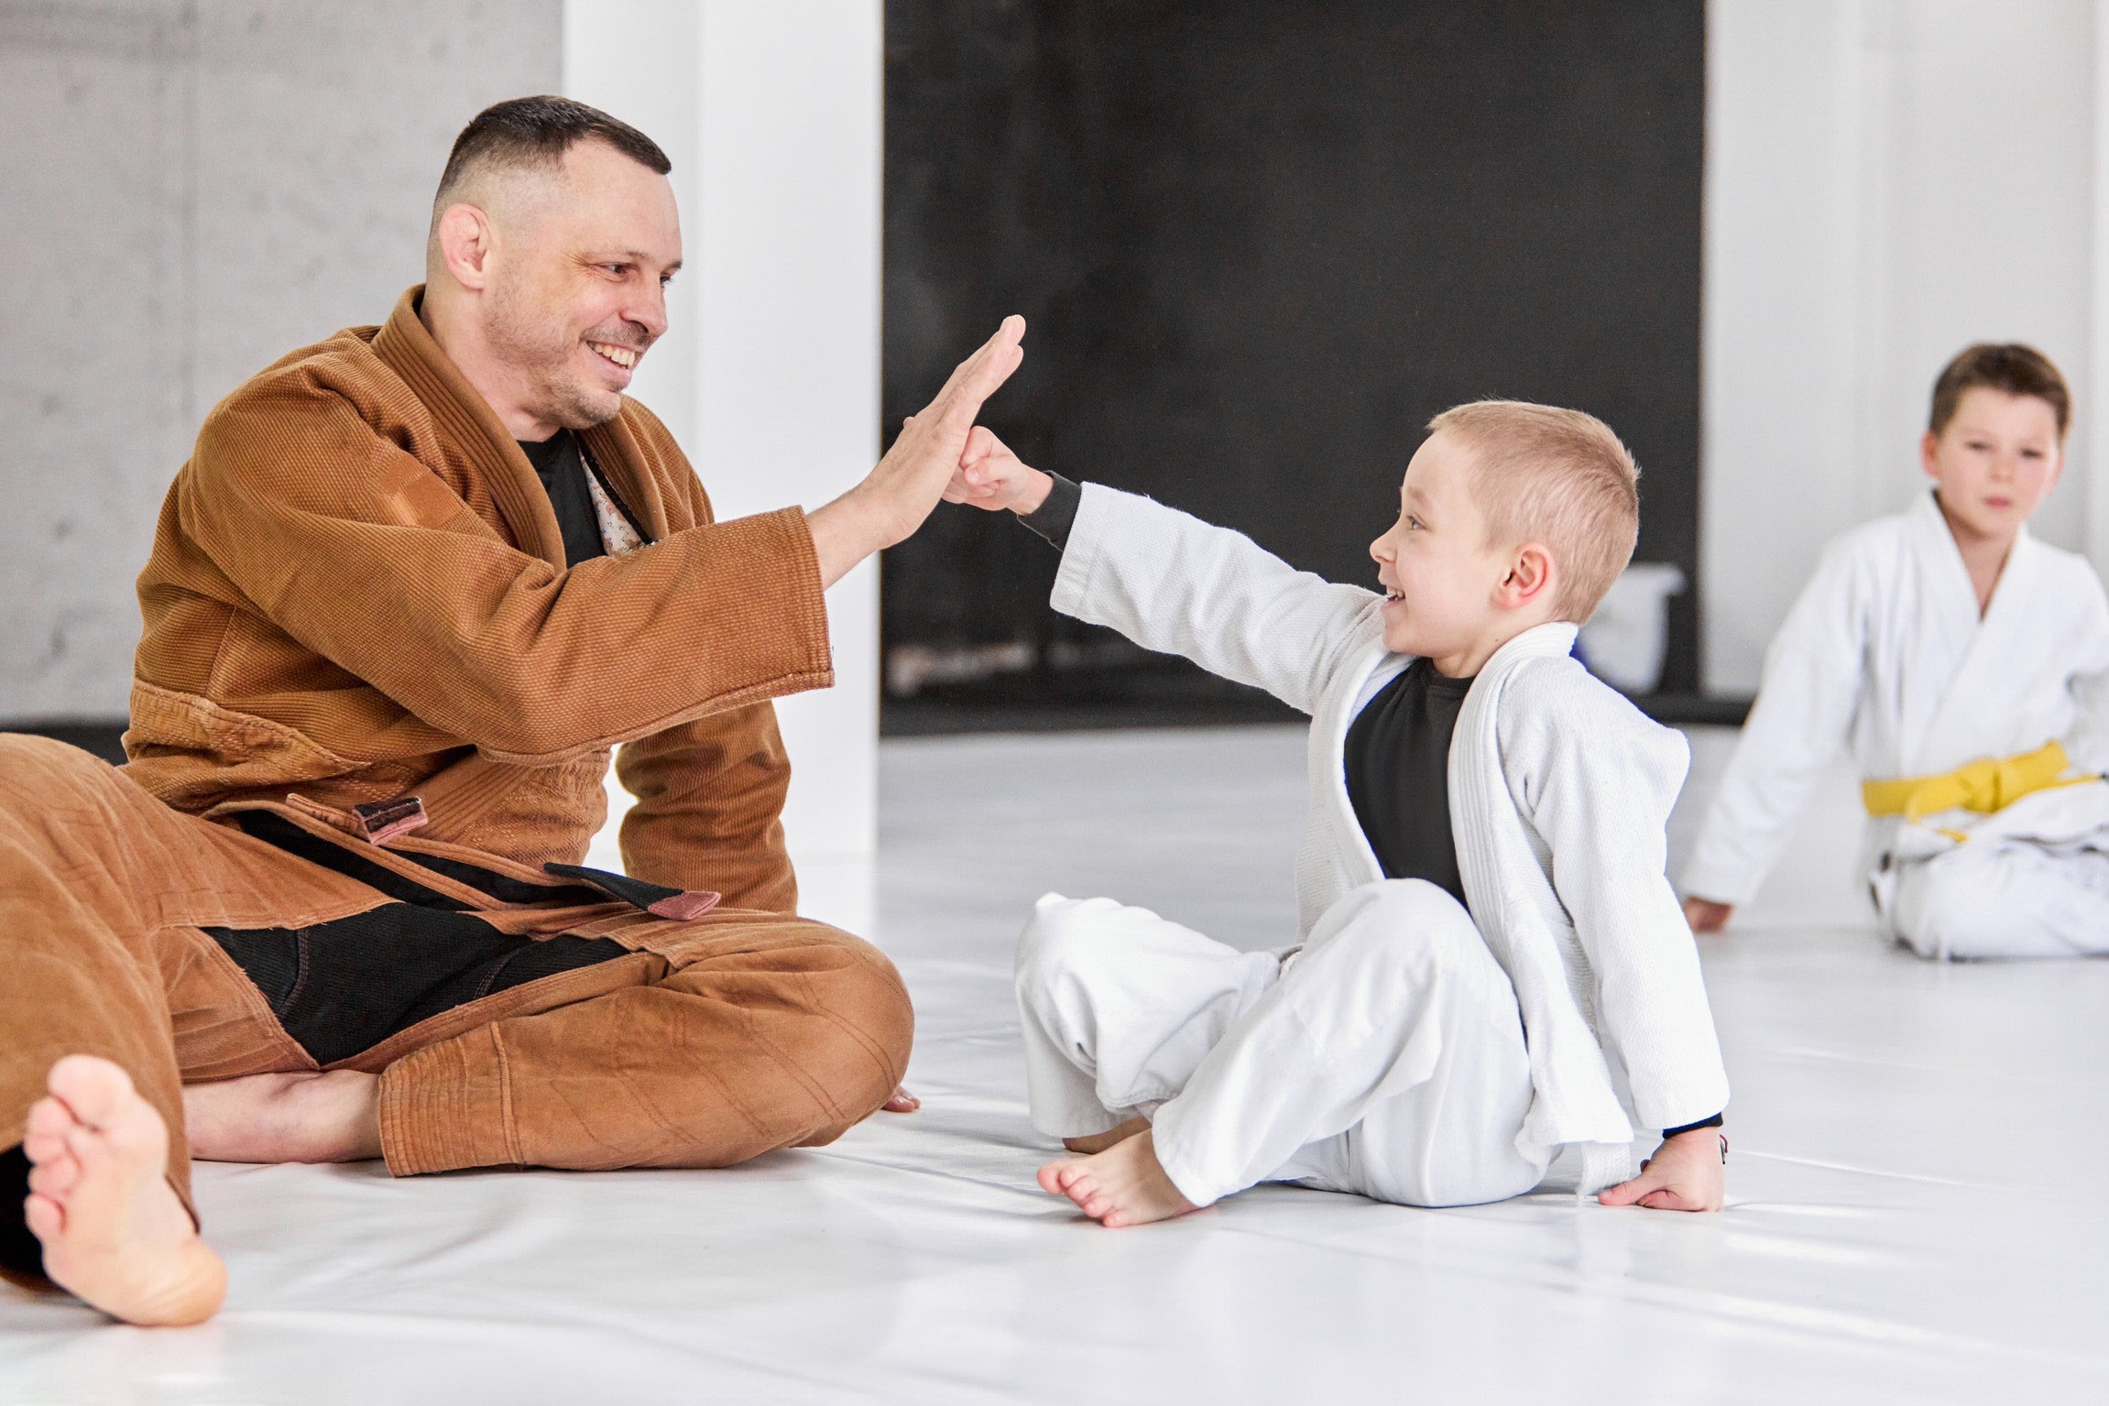

What would you recommend to club or organisations more broadly who are prepared but then don’t receive any issues or don’t know about them and now
experience that grows a perception that we don’t have any we don’t have any problems here. How would you help a club at a grassroots level or an organisation continue to prepare? Continue to scratch the surface and get different types of data from their members or employees? What role does technology play?
Elaine Heaney [00:18:30]
Yeah, absolutely. And I think again, to start with that kind of concept of that it doesn’t happen in our backyard is definitely a falsity because imagine that you took
a school and said, well, there’s never any bullying or harassment issues in a school and there’s never any kind of bad conduct in a school. I cannot imagine a school in the world where that would be true, and nor should it be. It’s humans interacting with each other, and there’s always going to be things attached to that. And it’s the same in any sporting club. There will always be issues and there will always be conduct matters.
But the way that you can minimise how bad they are in the first place is by proactively educating people with a code of conduct, a really strong code of conduct that sets the tone and a statement of your commitment
to child safety, for example. So that again, you’re sort of showing the behaviours that you’re expecting in your environment, and then you can also kind of work through educating that by having discussions with people and making sure that everybody is aware of what those behaviours are and what the expected tone is attached to it. I think it starts with the people
themselves creating that safe space and making sure that somebody, whether it be a member of protection information officer or NPO at community club level, or whether it’s a complaints officer who sits at the NSO or SSO level for the sport. Within your club and your sport, know who the person is to triage something to, you know, you might not have all the answers and be able to deal with any issue that arises, but know the person that does and speak to people and ask for help and advice.
Elaine Heaney [00:20:13]
And that’s your best route of triaging things through. And in order to do that, you’ve got to create a space where people are willing to speak up and know that they’ve got a route to do that. So whatever route it is that you choose to do that, whether it is having hotlines or online forums or whatever the sport or process has put in place, whether it’s under the knife or through the sport’s own processes, it’s really important that people know where to find the information that allows them to make the phone call or fill in the form or speak to the person. That means that they get their point heard.
Nathan Luker [00:20:50]
It speaks to really back to where we started with Scouts New South Wales program know it, live it, log it. You know that permanency of a program doesn’t go away and I think you can even do that in a mini fashion at a club level. And we build these at organisations, listen up, speak up frameworks and brands where you
demonstrate your listening maybe to a broader aperture than just misconduct. So it might be near misses in safety, it might be other just general ideas or stamping

out incivility, etc. It’s everything that happens in a way on the fringes on a regular basis that demonstrates that why on a regular basis, not just when there’s something really serious that happens.
Elaine Heaney [00:21:29]
Exactly. It’s the culture that you’re trying to create, Right. What we’re trying to do is affect culture change across the board. That’s the ethos of Play by the Rules. That’s the ethos of what the royal commission was trying to do. It’s trying to say identify the issues that exist and then work towards shifting people’s mentality, understanding education and attitude towards creating that environment that you want to see. And I think all of the things you’ve just discussed are how you take steps to effect that culture change.
Nathan Luker [00:22:00]
It was interesting. I was at a school recently doing a talk to the executive team and they very proudly brought in their bystander coaches and so putting the name to the side, etc., if that’s a good idea or not, from a branding perspective, how interesting to hear that that’s their version of that. So they recognise that there’s a large passive bystanders with young persons and schools, right? We’re going to create a whole cohort of SRC representatives, so student level, then parent volunteer level. So there’s even a bystander coach in the swap shop for uniform and then and then in a teacher level.
So they’ve taken approach to say this is a caring and supportive environment and the leadership from every level, including your peers, are here recognising because they knew through surveys, a serious passive bystander problem. We’re here to support you to get things out
of the shadow. And I think that was a really beautiful, simple example, I guess, of permanency of a program and showing that you’re here to listen before people speak up. I think that’s really important, that ordering is critical.
Elaine Heaney [00:23:03]
Absolutely. And the living and breathing thing comes from the humans that do every day, right? You can set policy as much as you want and put it on the shelf and it gathers dust. Or you can preach at people through newsletters and everything else. If that’s not landing and that’s not sitting with people and they don’t take it
forward, then it’s not affecting that change or discussion or empowering those people in the first place. So having people who are actively involved and care and are taking steps and are supported with resources, etc., to make sure that they feel like they know what their role is.
But is the only way to drive these programs forward. If we’re not empowering the people who matter, then it’s pointless.
Nathan Luker [00:23:43]
In the past episode, Anne-Marie Paterson did a wonderful quote, which was, you know, setting the tone at the top and making sure you notice the echo at the bottom. And I think that’s a beautiful way to particularly with young persons, you know, it’s critical to empower them to drive change themselves.
Elaine Heaney [00:24:00]
One of the scouts manager is a guy called Rob taught me was the standard you walk by is the standard you accept. And he used to.
Nathan Luker [00:24:07]
That’s on my window.
Elaine Heaney [00:24:09]
I love it. I just think it’s so clear. And it really sets the tone for, you know, people not just ignoring things and making sure that you’re stepping up and stepping in.
Nathan Luker [00:24:18]
Role models are such an important part of sport as they are in business. And really anything that people do always look to the top to inspire us. But particularly in sport, it’s something young persons look at on a daily, weekly basis and idolise you. Recently, the Argentina goalkeeper received the golden glove and then acted pretty poorly in what’s been described as a despicable act walking off the stage. And then in the A-League there was the running of the field which caused just
anarchy and injury. And it was a complete disaster. What impact does this have on young people and programs like Play by the Rules? Is it a positive in a weird way where you can contrast you then have examples of
how crazy they are? They’re just such larger than life behaviours of poor conduct. Or do they corrode and chip away what you’ve been building for years just in an instant? How do you feel about that?
Elaine Heaney [00:25:20]
I think, as you will know from my answers up to date, I will always say both because nothing is ever
straightforward. But at the same time, what I’ve loved about both of those situations is that everybody has had a huge outcry, particularly in terms of the way that the goalkeeper was assaulted on the field and the criminal conduct that’s followed from that.
Nathan Luker [00:25:43]
Yeah. Yep.
Elaine Heaney [00:25:44]
Yeah, there’s been there’s been an arrest and as there should be because that is incredibly unacceptable behaviour and those adults should be taking a good hard look at themselves and thinking about what the children in their life and other people in their life will take from watching that kind of behaviour. But the outcry against that has been wonderful to see. So Craig Foster’s done some brilliant interviews. If anybody wants to see what a really good attitude towards that is, you know, watch Craig Foster, listen to him and he condemns
them and he says it’s completely unacceptable and it should be. And the same with the crude gesture that was shown. I think, you know, tone is such an important part of operating as a role model and, you know, in a way that reflects the sport that you obviously love so much. And you just have to think about what you want to do to inspire future generations. If you’re a superstar soccer star at the World Cup, you know, think about the next generations in four years time, eight years time,

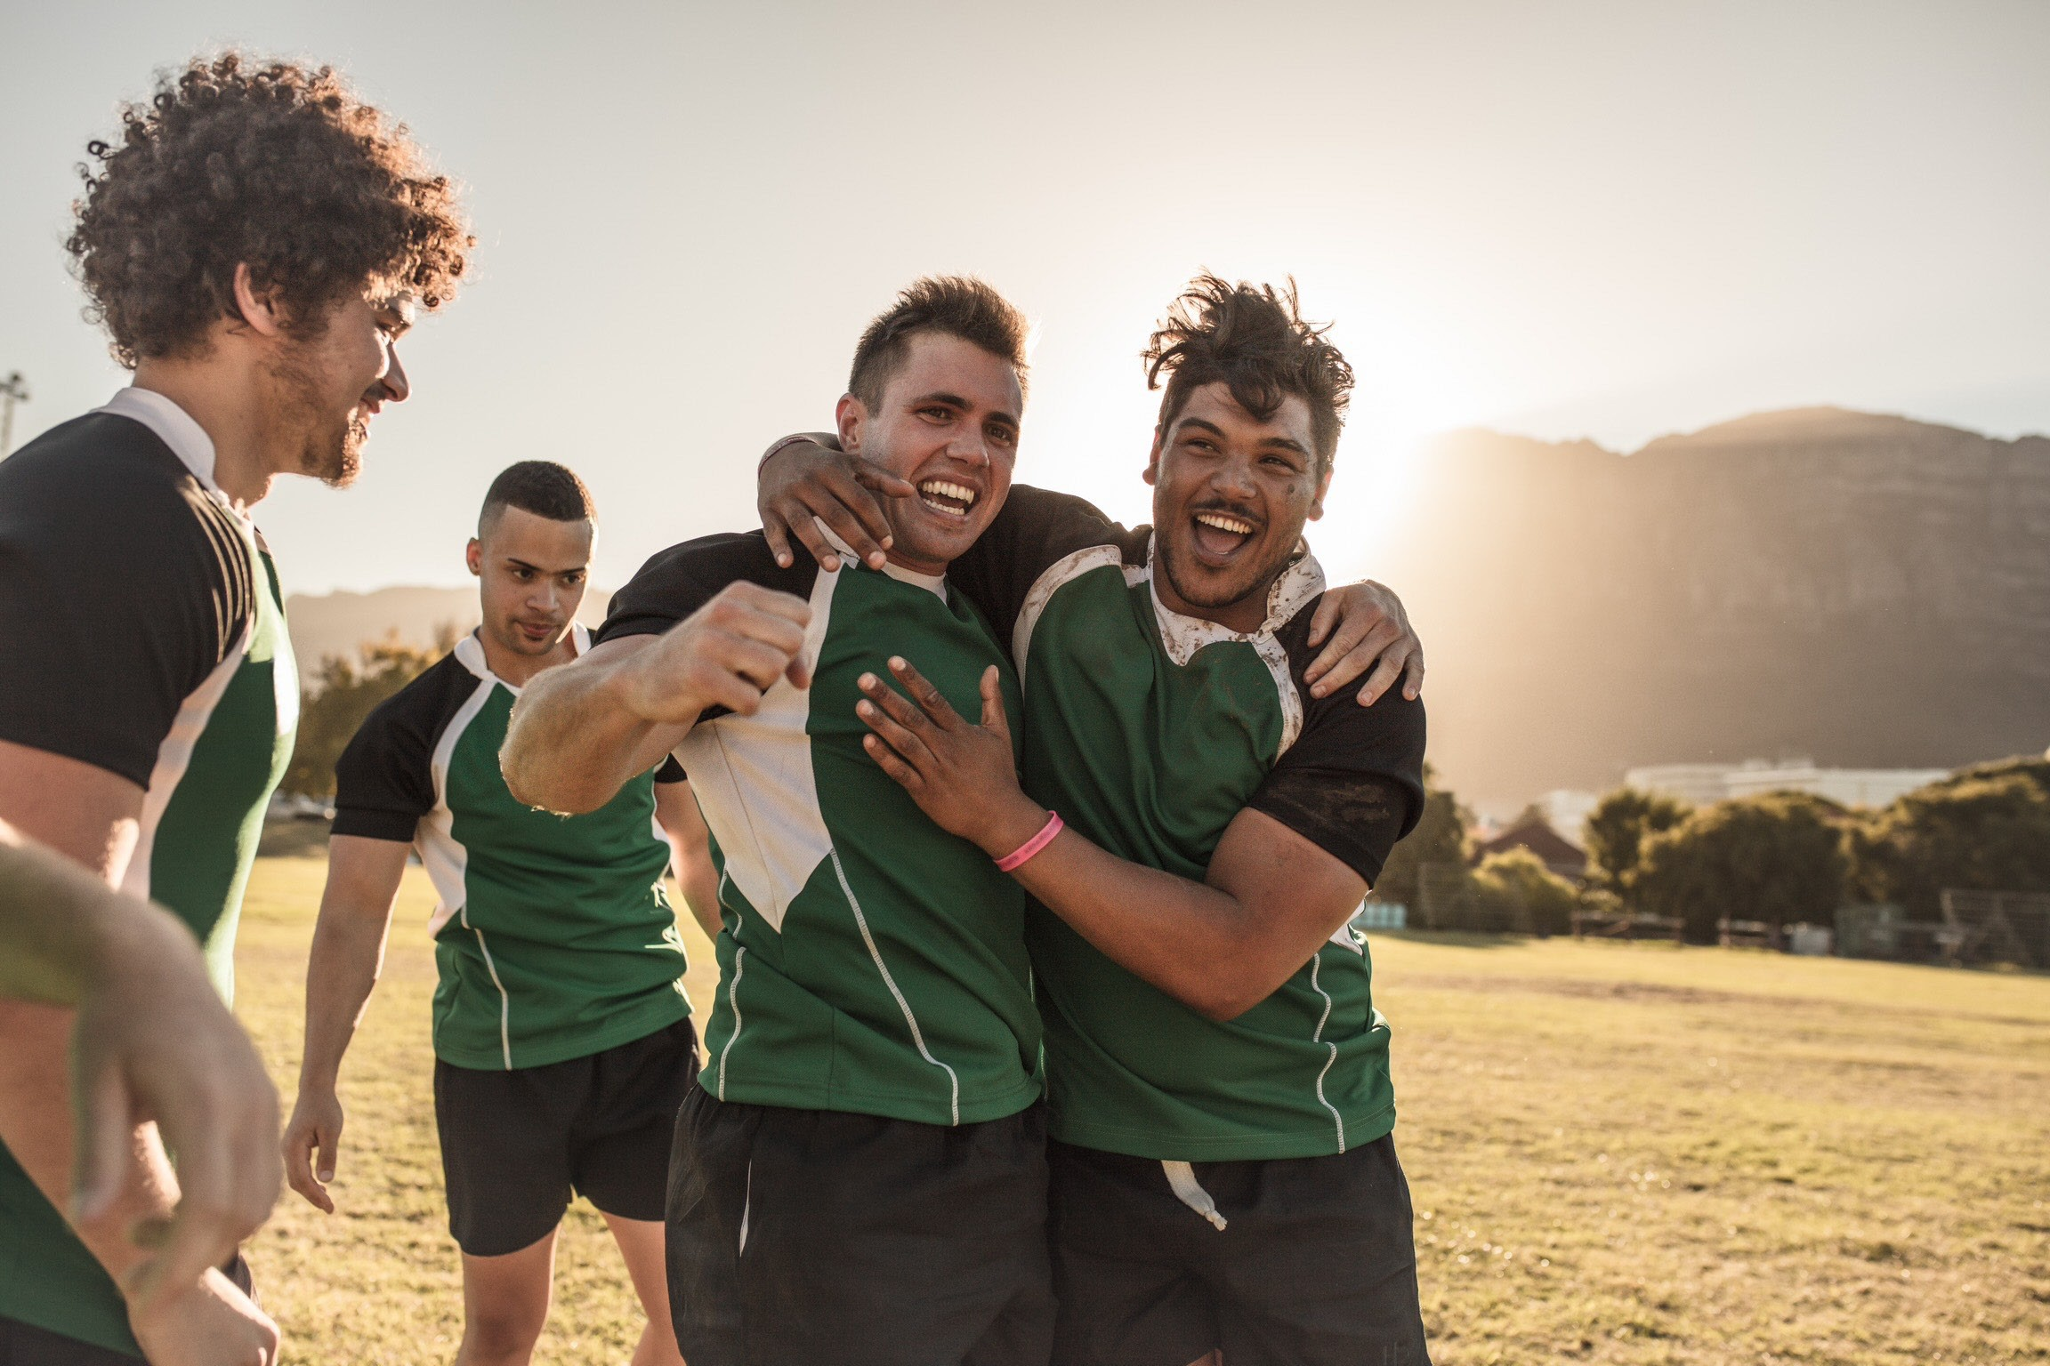

who’s the next kids that are going to be standing in your shoes? You know, what do you want? How do you want to inspire them? And I think the same with the Olympics all the time here. We’re on the golden decade towards Brisbane in 2032. There’s so much scope for us to set the tone as being a forward thinking, human rights understanding, welcoming, safe, inclusive space for sport. And the key people who represent us worldwide are those superstars on the stage. And if they’re not demonstrating good conduct, then what does that say about the rest of us? I think the audience members
in this situation are obviously they’re not sports stars. They are, you know, audience members who very clearly breached the code of conduct that should be set by entering into that. And I hope we’ll receive life bans because they should a soccer superstar should be thinking about kids that are watching and what that says.
Nathan Luker [00:27:41]
Absolutely. Yeah. Sometimes it’s important to show that human beings make mistakes and when things occur
in sport or at the upper echelons of leadership. But this type of behaviour has no place in sport.
Elaine Heaney [00:27:56]
And sometimes it is about the way you deal with it. If he can see that and recognise it and take steps to redress, redress is an important part of who we all are as a nation
and what we’re going through at the moment. And I think that individual redress is a really important thing to think about, is how do you make right what you did wrong and think about how you can kind of set the tone for the future.
Nathan Luker [00:28:20]
Well, we’ve got one more question. I’d love you to finish the sentence. Great cultures rely on...
Elaine Heaney [00:28:27]
People feeling empowered, I think, more than anything. So just give people the impetus, the dance, the music, the songs, the artwork, the something that inspires them to make this happen. And so if you don’t start with the people, boring policies on a shelf will get you nowhere.
Nathan Luker [00:28:47]
Amazing. Thanks, Elaine. Appreciate you joining us.
Elaine Heaney [00:28:52]
No problems, Nathan. Thanks very much. Take care.
Nathan Luker [00:28:59]
Thanks for listening to RelyOn. You can access the show notes from this episode, download resources and listen to other episodes at relyplatform.com. If you enjoyed the episode, we welcome you to submit a review or send an email to hello@relyplatform.com.

The collaboration that’s making the pitch Proud

The A-Leagues’ Pride Celebration is a force for change, making football accessible, inclusive and safe for LGBTQIA+ fans and players across the entire league.

L-R: A-League Players Kayla Ann Morrison, Isabel Hodgson, and Josh Brilliante wear Pride uniforms while standing in front of a large letter sign that says “TOGETHER”

Hosted at AAMI Park on 26 February, A-Leagues clubs Melbourne Victory and Adelaide United Men’s and Women’s teams played in the marquee match Pride Cup wearing rainbow-banded jerseys to a crowd waving progressive pride flags in the stands.

The collaboration between the A-Leagues and Pride Cup began 18 months ago, with the inaugural Pride Cup played in 2022 with the hope of making it an annual highlight of the football calendar.

The Celebration featured rainbow corner flags, captain arm bands, guards of honour and some clubs partnering with local pride community groups. The dedicated Pride Bay in the stadium provided a safe place for LGBTI+ fans to enjoy the game, with stalls from LGBTI+ support services available nearby. As part of the Pride Celebration, $1 from every ticket sold was donated to Pride Cup’s community fund to support community clubs and their own pride events.

“We reached out to Pride Cup a couple of years ago because we want every person involved with our game – fan, player, coach, staff member – to feel safe and included in every part of the game,” said Danny Townsend, CEO of the A-Leagues.

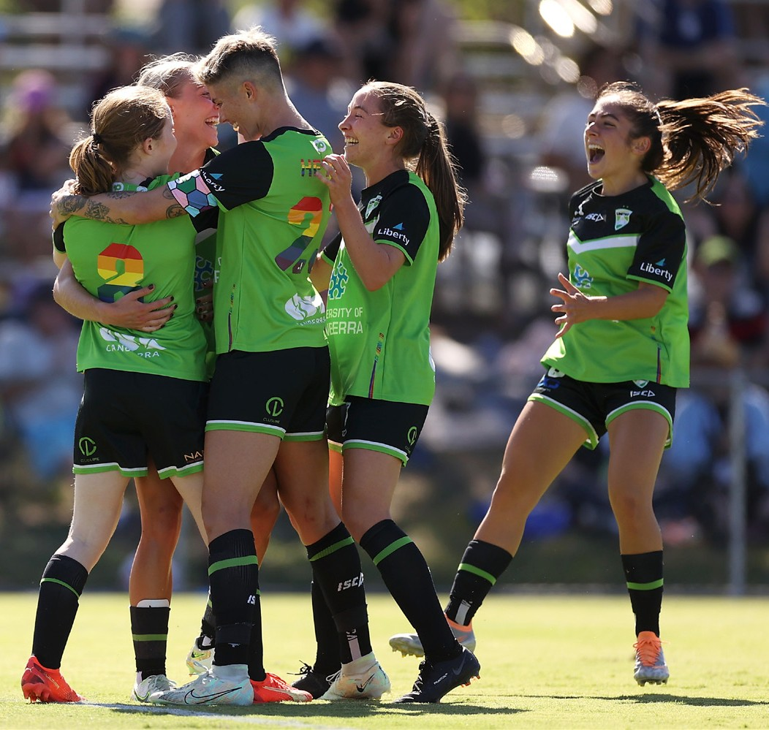

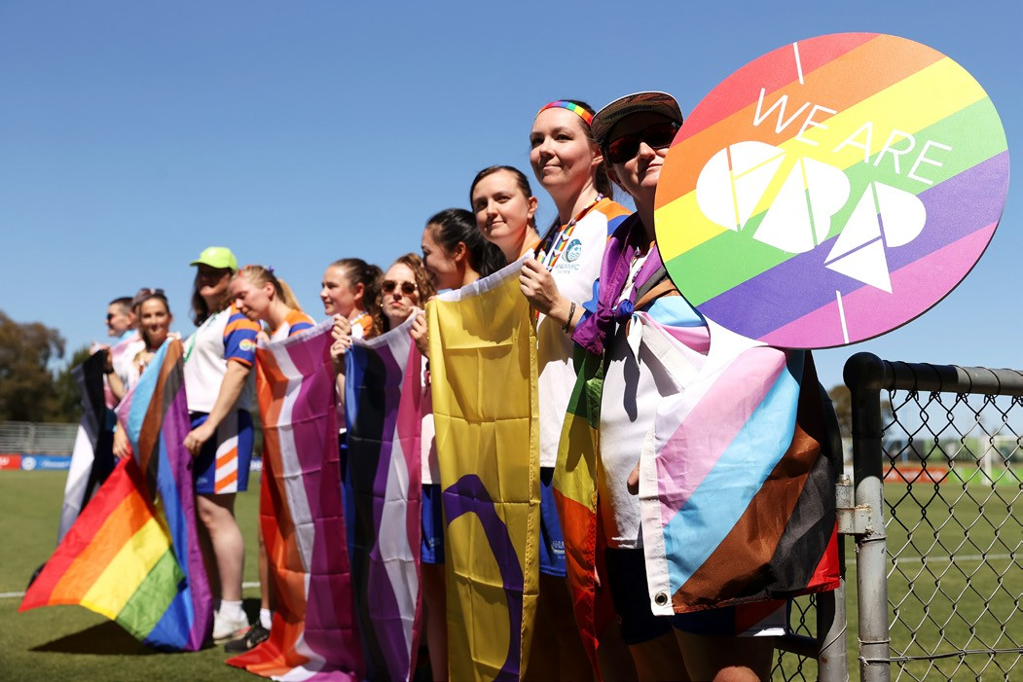
“At the heart of this Celebration is education. We work closely with our stakeholders on a wide range of
initiatives to ensure safety and inclusion at every level.

This includes a partnership with GoBubble who provide technology to protect our clubs, players and fans from online abuse, work with our venues to provide additional anti-discrimination training and information for staff, and education and training sessions delivered by our partners Pride Cup to every single APL staff member, club CEO and men’s and women’s players.”

Pride Cup CEO, James Lolicato, views these events as an opportunity to change culture within clubs.

“Only 6% of young LGBTI+ people participate in sport because they don’t feel safe or welcome to. There are multiple barriers that work together but by far the biggest barrier is homophobic and transphobic language, even casual comments like ‘that’s gay’ signify to LGBTI+ people that they aren’t especially safe or welcome,” said Lolicato.

Education plays an important role in making this cultural change. Running a Pride Cup is an opt-in process that starts with an acknowledgement that there is room for
We hope more young players grow up feeling like they belong in
football and are free to express their authentic selves ... This is only
the beginning.

improvement within clubs, and those who choose to participate are motivated to change. The judgement-free education sessions and events can reduce homophobic language in a club by up to 40%.

“The first step we can take is to change the way we speak to one another on and off the field and position the importance of language usage and behaviour in clubs.

“It’s important for a club to work together to determine what sort of environment they want to create and what identity they want to have in their community, social change can’t happen without people working together towards a shared goal,” said Lolicato.

Pride Cup works with clubs at the top and all the way down to grassroots level. Numerous community clubs across sports like basketball, cricket, Australian Rules, football, netball, roller derby, and tennis have been involved in their program. Clubs can apply through their website to receive a Pride Cup handbook, and from there clubs can register their event and request a 30-
or 90-minute education session on inclusion for club members.

Lolicato continued, “ We hope more young players grow up feeling like they belong in football and are free to express their authentic selves because they have never been made to feel excluded or unwelcome. This is only the beginning.”

Townsend noted that the A-Leagues is getting the foundations right to make positive change and help LGBTI+ people to feel included, accepted, and proud in sport.

“The A-Leagues have made progress over the past two seasons, but we have plenty of work still to do. Every person involved with our game - fan, player, coach, staff member - has the right to feel safe and included in every part of the game and so we will continue until this is realised.”

Learn more about the Pride Celebration at the Pride Cup website and Keepup.com’s news article on Pride Cup.

Subscribe to
Play by the Rules
Come and join the 130,000+ subscribers to Play by the Rules - it’s a great way to keep up-to-date with safe, fair and inclusive sport.

Back Issues
You can access each back issue for this magazine by visiting this page on the Play by the Rules website. All the feature articles and significant news items are listed here.

Share and spread the word
One easy way to keep up to date and support safe, fair and inclusive sport is to share Play by the Rules across social media. We post every day on Facebook and Twitter and have audio files on Soundcloud
and an extensive collection of videos on YouTube and Vimeo.

http://facebook.com/playbytherules

http://twitter.com/playbytherules

@playbytherulessport

24 Play By The Rules | Magazine Issue 41
24

Play by the Rules and Sport Integrity Australia courses in one place

PBTR courses have now been integrated into the Sport Integrity Australia LMS (Learning Management System) which is co-branded with Play by the Rules. You can now find all of these
PBTR courses in one, easy to find place. Click here for the PBTR e-learning hub link and see below for a list of the courses you can access:

- Revised Child Protection Online Course
- Harassment and Discrimination Online Course
- Member Protection Information Office Course
- Complaint Handling Training
- Inclusive Coaching
- Creating an LGBTI+ Inclusive Club
- All mini-courses.

Hosting the Play by the Rules online training modules on the Sport Integrity Australia e-learning hub creates a single destination for all sporting codes and administration staff to access the
appropriate educational materials and training on sport integrity and will vastly improve the user experience in the process.

Bringing together the courses was a key recommendation from the Wood Review, which proposed a single identifiable education and outreach platform be established to develop and coordinate education, training and outreach courses.

The Play by the Rules online courses will be available on our website from 17 June 2021. The courses can be found at www.elearning.sportintegrity.gov.au

Our Partners

Click here for the new eLearning hub
– a collaboration between PBTR and Sport Integrity Australia – now hosting all integrity online courses in one single click destination
Did you know that Play by the Rules is one of the best examples of a Collective Impact approach to addressing sport issues in the country? Play by the Rules is a collaboration between multiple partners.

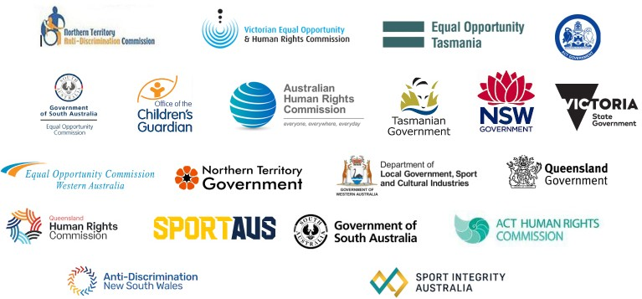

To make Play by the Rules possible, we also work with

